HDMI Chainable Extender
over CAT5e/6

HD1000-1002

User’s Manual

Version 1.0

- Introduction

Thanks for purchasing the HDMI Chainable Extender over CAT.5e/6. We recommend that you read this manual thoroughly and retain for future reference.

  - Features

The HDMI Chainable Extender over CAT.5e/6 allows you to extend video and audio up to 100 meters distance between source or computer and monitor or projector. With the built-in video and audio signals enhancement, you can gain the best video resolution quality and audio stereo sound while listening, and no any additional software needed. Furthermore, the installation and operation are easily more than expected. With using in extension facilities of video and audio, this product, The HDMI Chainable Extender over CAT.5e/6, delivers worthy of performing efficiency and value-added.

- Expandable Receiver, each Receiver Unit with cascade function enables to link the other two (2) Receiver Units consecutively extending another 100m distance, and continue expanding corresponding to custom demand as likely Cascade/Tree Chain web architecture spread.
- Uses easy to install, inexpensive CAT. 5e/6 cables.
- Each pair (TX & RX) extends the signals up to 100m (330 feet).
- Supports video high resolution up to 1920x1200, 1080p.
- HDTV compatible (720p, 1080i, 1080p).
- Supports High Definition Audio (HD), 5.1/6.1/7.1 Surround Sound.
- Cascaded-chainable receiver up to 10 layers.
- Supports RS-232 (Serial).
- IR (Infrared remote) enabled.
- Support Local HDMI monitoring port.
- Each receiver (remote) links cascade-chainable 2 receivers.
- Rack mountable.

  - Package Contents

- HDMI Extender Transmitter x 1
- HDMI Extender Receiver x 1
- Power Adaptor DC 5V x 2 ( set units ) or 1 ( single unit )
- User’s Manual x 1

1R40H2088

2. Specifications

2.1 General

 |  |  |  |  | HD-1000TX (Transmitter) | HD-1002RX (Receiver)
Console Connectors |  | HDMI Output |  |  | HDMI (Female) |  | HDMI (Female)
 |  | RS-232 Control Port |  |  | Phone Jack |  | Phone Jack
PC Connectors |  |  | HDMI Input |  | HDMI (Male) |  | N/A
Extension Port |  |  | RJ-45 |  | Full HD Video / Audio Extension
RJ-45 |  |  |  |  | 1 (Line Out) |  | 3 (Line In or Line Out)
Cascaded-Chainable |  |  |  |  | N/A |  | Yes, up to 10 layers
Audio |  |  |  |  | Supports High Definition Audio (HD) 5.1/6.1/7.1 Surround Sound
IR |  |  |  |  | Bi-directional
LED Indicators | Local |  |  | Power | Red LED
LED Indicators |  |  |  | Link | Red Green
LED Indicators | Remote |  |  | Power | Red LED
LED Indicators |  |  |  | Link | Red Green
DDC Supported |  |  |  |  | DDC, DDC2, DDC2B
Extension Cable Type & Length |  |  |  |  | CAT.5e / CAT.6 Max. Length: 100m
Max. Video Resolution |  |  |  |  | 1920x1200@60Hz, Full HD 1080p, 48-bit
Wide Screen Supported |  |  |  |  | Yes
OS Compatibility |  |  |  |  | OS Independent
Power Supply |  |  |  |  | External DC 5V / 2A Power Adapter
Dimension ( L x W x H ) |  |  |  |  | 115 x 91 x 28 mm
Weight |  |  |  |  | 340g |  |  | 380g
Housing material |  |  |  |  | Metal
Operating Temperature |  |  |  |  | 32 - 122F ( 0 - 50C )
Humidity |  |  |  |  | 0% - 80% RH

2R40H2088

3. Detail and connection diagram

  - Detail Picture
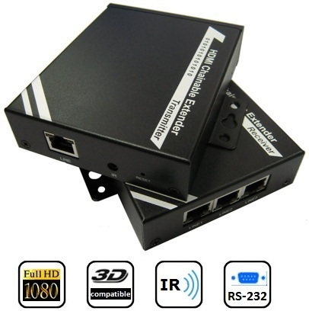
Transmitter (TX) – Front View Transmitter (TX) – Rear View

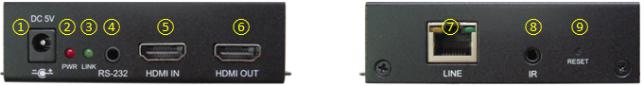

: | Connected to Power Adapter DC 5V/2A | □: | HDMI OUT, connected to display
: | Power LED (Solid Red when power present) | : | CAT.5e/6 cable connected for data out
: | Link LED (Solid Green when link present) | : | IR Blaster Emitter
: | RS-232 control port | : | Reset Button
: | HDMI IN, connected to HDMI source

Receiver (RX) – Front View Receiver (RX) – Rear View
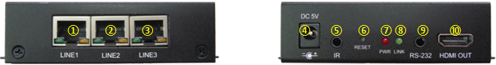

: | CAT.5e/6 cable connected for data in or out | □: | Reset Button
: | CAT.5e/6 cable connected for data in or out | : | Power LED (Solid Red when power present)
: | CAT.5e/6 cable connected for data in or out | : | Link LED (Solid Green when link present)
: | Connected to Power Adapter DC 5V/2A | : | RS-232 control port
: | IR Receiver | : | HDMI OUT, connected to display

3R40H2088

  - Application Diagram

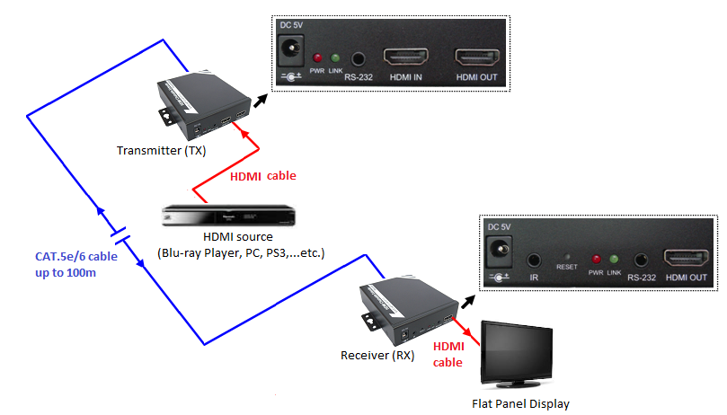

Transmitter Installation

- UTP Cable connected with Transmitter to get the best display quality, please use CAT.5e/6 Cable, and the cable connector node is to connect to Transmitter LINE port (RJ45)
- Connect the IR Blaster Emitter cable or RS-232 to 3.5mm adapter to the Transmitter Unit IR Port or RS-232 port if necessary.
- Connects Transmitter with HDMI cable to HDMI connector of Player, PC, PS3…etc.
- Connects Transmitter with HDMI cable to HDMI connector of Display Monitor if necessary.
- Plug DC 5V/2A power adapter.

Monitor HDMI port connected

UTP cable connected
PC HDMI port connected

Power Adapter DC5V/2A
IR Blaster Emitter
RS-232 to 3.5mm

4R40H2088
Receiver Installation

- UTP Cable connected with Receiver to get the best display quality, please use CAT.5e Cable, and the cable connector node is to connect to Receiver LINE1 or LINE2 or LINE3 port (RJ45)
- Connect the IR Receiver cable or RS-232 to 3.5mm adapter to the Receiver Unit IR Port or RS-232 port if necessary.
- Connect Receiver with HDMI cable to HDMI connector of Display Monitor.
- Plug DC 5V/2A power adapter.
Monitor HDMI port connected

Power Adapter DC5V/2A
RS-232 to 3.5mm

IR Receiver
LINE port (RJ45)

Cascade Chain Connection

- Use UTP Cable connected with Receiver to link the other two (2) Receiver Units consecutively to extend another 100m distance, the cable connector node is to connect to Receiver LINE1 or LINE2 or LINE3 port (RJ45), as long as the LINE port is not occupied, and user can continue expanding corresponding to custom demand as likely Cascade/Tree Chain web architecture spread.
- Connect the IR Receiver cable or RS-232 to 3.5mm adapter to the Receiver Unit IR Port or RS-232 port if necessary.
- Connect Receiver with HDMI cable to HDMI connector of Display Monitor.
- Plug DC 5V/2A power adapter.

Monitor HDMI port connected

Power Adapter DC5V/2A
RS-232 to 3.5mm

IR Receiver
LINE port (RJ45)

5R40H2088

Each Receiver with three (3) Line port, one is used for source input, and the other two are used for expanding source to other receivers. User can choose any LINE port as source input at random, and use the other two LINE port for expanding source to next tier receiver as long as the LINE port is not occupied.

Network Switch Extending

- The maximum distance between each tier could be up to 100 meters long, while this could be extended through Network Switch. User can add one Network Switch to extend another 100 meters.

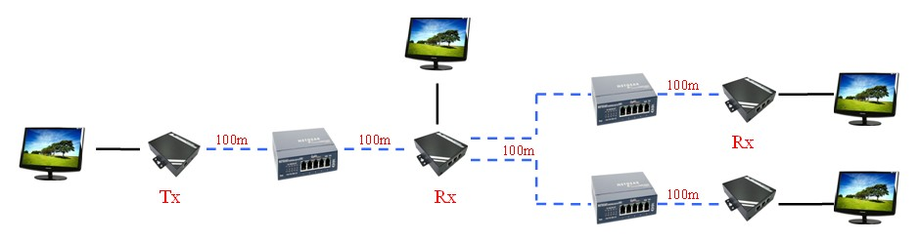

- The more Network Switches, the longer distance extended. The number of Network Switches is as many as user want.

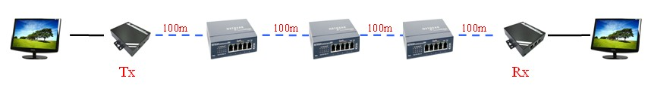

6R40H2088

  - Connection Diagram

- Single Source Extension

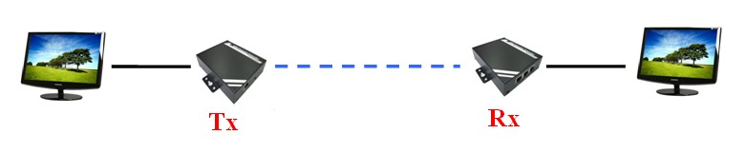

(2) Single Source Extension and Receivers Cascade Chaining

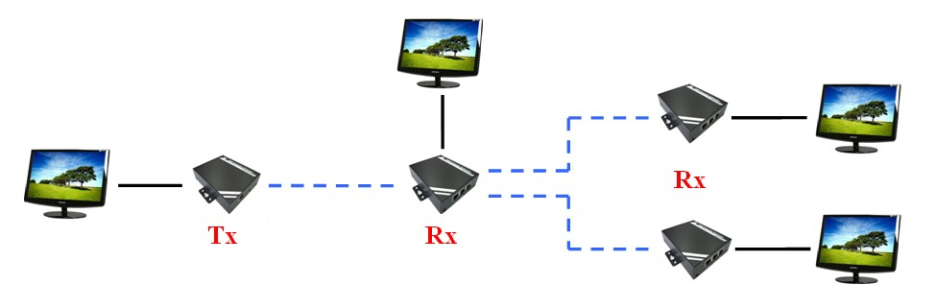
(3) Single Source with Multiple Receivers Cascaded
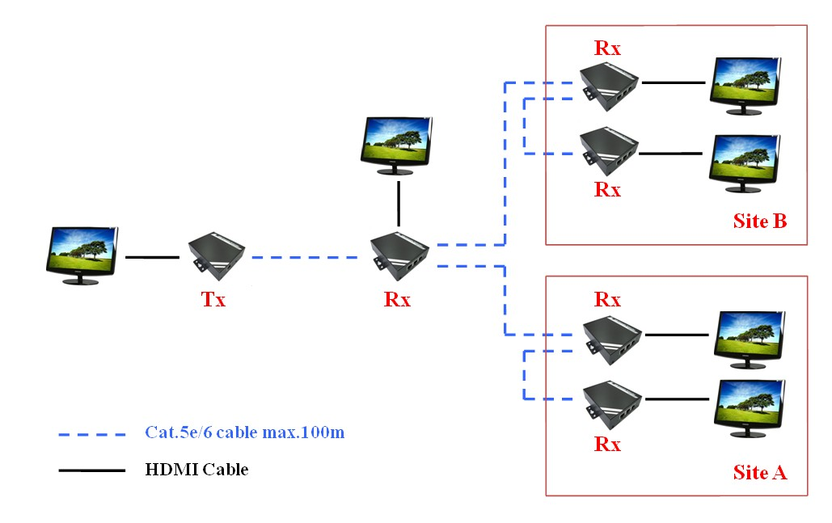
7R40H2088

Disclaimer
Information in this document is subject to change without notice. The manufacturer does not make any representations or warranties (implied or otherwise) regarding the accuracy and completeness of this document and shall in no event be liable for any loss of profit or any other commercial damage, including but not limited to special, incidental, consequential, or other damages.

No part of this document may be reproduced or transmitted in any form by any means, electronic or mechanical, including photocopying, recording or information recording and retrieval systems without the express written permission of the manufacturer.

All brand names and product names used in this document are trademarks, or registered trademarks of their respective holders.

FCC Statement
This device generates and uses radio frequency and may cause interference to radio and television reception if not installed and used properly. This has been tested and found to comply with the limits of a Class B computing device in accordance with the specifications in Part 15 of the FCC Rules. These specifications are designed to provide reasonable protection against such interference in a residential installation. However, there is no guarantee that interference will not occur in a particular installation. If this device does cause harmful interference to radio or television reception, which can be determined by plugging the device in and out, the user can try to correct the interference by one or more of the following measures:

- Reorient or relocate the receiving antenna.
- Increase the separation between the device and receiver.
- Connect the computer into an outlet on a circuit different from that to which the receiver is connected.
- Consult the dealer or an experienced radio/TV technician for help.

CE / FCC


2R40H2088

