

2-Port / 4-Port
COMBO FREE
(USB&PS/2)
KVM SWITCH

User’s Manual

Version 2.0
Index
1. Introduction….…………………………………………………………………………...2
1.1 Features….……………………………………………………………………………………………...2
1.2 Package Contents….……………………………………………………………………………….....2

2. Specifications…………………………………………………………………………....3
2.1 General….………………………………………………………………………………………………3

3. System Requirements….………………………………………………………………4

4. Installation….……………………………………………………………………………4
4.1 Single Installation….………………………………………………………………………………......4
4.2 Rack Mounting….…………………………………………………………………………................7

5. Operations….……………………………………………………………………………8
5.1 Push Button….………………………………………………………………………………..............8
5.2 Hot-Key Operation….……………………………………………………………………..................8
5.3 Audio Selection….……………………………………………………………………......................10

6. Sun Microsystems Function Key Emulation….…………...……………………..13

Appendix (附錄)
Quick Guide (快速使用說明)….………………...................................................................14

1. Introduction
Thank you for your purchase of Combo Free KVM Switch! You now have a high quality, durable system that will enable you to control 2/4 Host computers and/or servers by using PS/2 and/or USB Connectors from one console (PS/2 & USB Mouse, PS/2 & USB Keyboard, and Monitor).

  - Features
- Console your Keyboard/Mouse via either way of PS/2 and/or USB arbitrarily.
- Complex connections with PCs via either way of PS/2 and/or USB arbitrarily.
- Controls 2 / 4 computers from a single console (Keyboard/Mouse) over PS/2 and/or USB connections.
- Supports Windows, Linux, Mac OS9/OSX, Sun Microsystems.
- Emulates a keyboard on each PC to allow your computers to boot normally without a keyboard error.
- Supports hot-swap. All devices connected to the KVM can be added or removed at any time, without shutting the unit down.
- Supports 2 types of switching: (1) Hardware Push Button, (2) Hot-Keys on PS/2 and/or USB of keyboard arbitrarily.
- Supports Auto-Scan function to alternate video between computers in preset intervals.
- Supports LED display for PC status monitoring.
- Supports VGA resolutions up to 2048 x 1536 @ 85HZ.
- Supports Beeper during switching enabled.
- Self powered through PS/2 and/or USB connection.
- Fully compliant with the USB 1.1/ 2.0 specification.

1.2 Package Contents

The product you purchased should contain the following equipment and accessories:
1 x 2-Port or 4-Port Combo Free KVM Switch
2/4 x Combo Custom 4-in-1 Cable (2 x PS/2 + USB + VGA) Cable
1 x User's Manual

2. Specifications

2.1 General

Specification
Number Of Computers Controlled |  | 2 / 4
Selection Method |  | Push Button and Hot-Key (PS/2 and/or USB Keyboard)
LEDs |  | Red for PC Selection  Green for PC On-Line ready
PC Connectors | Video | 2 / 4 x HDB -15 female
PC Connectors |  | ( USB & PS/2 signal combined )
PC Connectors | Speaker | 2 / 4 audio female jacket (audio version)
PC Connectors | Microphone | 2 / 4 audio female jacket (audio version)
Console Ports | Keyboard | 1 x 6 pin mini-DIN female / 1 x USB A type female
Console Ports | Mouse | 1 x 6 pin mini-DIN female / 1 x USB A type female
Console Ports | Video | 1 x HDB -15 female
Console Ports | Speaker | 1 x audio female jacket (audio version)
Console Ports | Microphone | 1 x audio female jacket (audio version)
Auto-Scan Interval |  | From 5 to 250 Seconds
DDC, DDC2 monitor |  | Yes (Max. Resolution: 2048x1536) @ 85Hz
Hot Swappable |  | Yes
Operating systems supported |  | Windows 98SE/ME/2000/XP/Vista/2003 Server, Linux
 |  | Mac OS9/OSX and Sun Micro System
Device driver |  | No Need
Power |  | By PS/2 and/or USB or External Power Adaptor (Optional)
Cable Length |  | 6 feet (1.80 Meter)
Dimensions (L X W X H) |  | 2-Port : 14.0 x 8.5 x 4.5 cm (5.5 x 3.3 x 1.7 inches)
 |  | 4-Port : 21.5 x 8.8 x 4.5 cm (8.5 x 3.4 x 1.7 inches)
Unit Weight |  | 2-Port : 450 g
 |  | 4-Port : 650 g
Housing material |  | Metal
Operating Temperature |  | 32~ 122°F (0~ 50°C )
Humidity |  | 0%~80%RH

3. System Requirements
Console
A VGA, SVGA, Multisync monitor capable of the highest resolution.
PS/2 and/or USB Keyboard/Mouse

Computer or Server
The following equipment must be equipped with each computer or server.
- A VGA, SVGA or Multisync card.
- Type A USB port and/or PS/2 6 pin mini-DIN for Keyboard and Mouse.

Cables
The Combo Free KVM Switch must be used specific custom 4-in-1 cables.
To purchase the specific cable sets, please contact your dealer.

4. Installation

LED Indicators:

Selected : RED LED indicates that the KVM Switch is selected to the corresponding PC.
On-Line : GREEN LED indicates that the KVM Switch is ready to the corresponding PC.

Reset Switch :

Press this switch when a system reset. This switch must be pushed with a thin object, for example, such as the end of a paper clip, or a ball point pen.

4.1 Single Installation

Precaution:

1. With under running OS Windows 98 , we sugget that the PC must be plugged
to PS/2 ports, because of Windows 98 is not support installation at first time as through USB HID installation driver.

2. There are some of older PCs can support USB ports during booting, but you need to open BIOS USB setting at first.

- The KVM switch does not support the USB keyboard which has built-in
USB HUB.
Console connecting:

Plug either your USB keyboard, mouse and/or PS/2 keyboard, mouse arbitrarily and VGA video into the Console ports located on the KVM Switch’s front panel.
( Note: No matter what you plugged even thought USB mouse with PS/2 keyboard or PS/2 mouse with USB keyboard are available working to the KVM Switch unit.)

System connecting:

Use KVM custom cable sets to connect any available PC ports to the video and
either USB or PS/2 ports alternatively, or even USB & PS/2 both all connected to the computers you are connecting up.

( Note: The custome cable set, as Fig. 1, is supplied cable set with this package; any additional sets is required purchase separately.)
To purchase the custom KVM cable sets, please contact with your dealer.

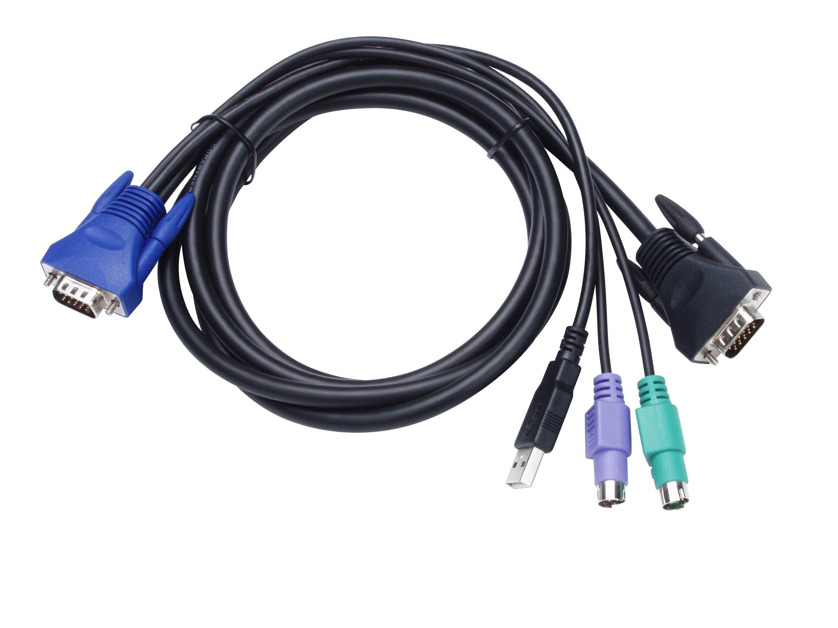
( Fig 1 ) combo custom 4-in-1 cable

Tune monitor display quality:

If you are using LCD monitor connected with Combo Free KVM switch with AUDIO and feel the quality is not comfortable to you, then you can push monitor panel Auto-Adjusting function button to tune gain better display quality at just the first time. After then, the display quality will be remained better condition continuously.

This KVM Switch with custom specific cable set provide three connecting methods.

- Plug Speaker, Microphone,USB, PS/2 ( keyboard/mouse) ports and VGA into PCs at same time, recommended in priority. ( Fig. 2 )

( Fig. 2 ) Speaker, Microphone,PS/2 & USB and VGA connected at same time.

- Plug only Speaker, Microphone,PS/2 (keyboard / mouse) ports and VGA into PCs. ( Fig. 3 )

( Fig. 3 ) Speaker, Microphone, PS/2 and VGA connected.

- Plug only Speaker, Microphone,USB and VGA into PCs. ( Fig. 4 ).

( Fig. 4 ) Speaker, Microphone, USB and VGA connected.

4.2 Rack Mounting ( Optional ) for 4-Port Combo Free KVM Switch only.

Mounting brackets to the KVM Switch unit for standard 19-inch rack cabinet.

- Screw the mounting brackets into the sides of the KVM Switch unit.
- Slide the KVM Switch unit into the rack cabinet and secure it to the rack.

5. Operations

The 2 / 4-Port Combo Free KVM Switch has the ability to switch the keyboard, video, mouse, audio, microphone simultaneously.
Note: When using the two-step Hot Key sequences, the keys must be pressed within 5 seconds; otherwise the Hot Key action will be terminated.

5.1 Push Button on front panel

5.2 Hot-Key Operation ( Either PS/2 and/or USB Keyboard )

Note: If your keyboard is without < Scroll Lock > button,
please press < Caps Lock > or <Num Lock >
instead of Scroll Lock (please reference 5.2.0).
5.2.0 Instead hotkey Selection

Hot Key:
[Ctrl] → [Ctrl] → [Caps Lock] → [Enter] : The hotkey changed to [Caps Lock]
[Ctrl] → [Ctrl] → [Num Lock] → [Enter] : The hotkey changed to [Num Lock]
[Ctrl] → [Ctrl] → [Scroll Lock]→ [Enter] : The hotkey reversed to [Scroll Lock]

Note : The default hotkey setting is <Scroll Lock>, after you changing the hotkey setting, the new setting will effect on the KVM until power off or reset.

5.2.1 PCs Selection

Hot Key:
[Scroll] → [Scroll] → [ 1 ] → [Enter] or
[Scroll] → [Scroll] → [ 2 ] → [Enter] or

[Scroll] → [Scroll] → [ 3 ] → [Enter] or
[Scroll] → [Scroll] → [ 4 ] → [Enter]
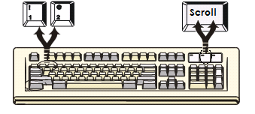

You can synchronize the PC selection, by using the following two-step Hot Key sequence. To send commands to the Combo Free KVM Switch, press the [Scroll] key twice (Step 1), then press key [1] or [2] or [3] or [4] and [Enter] (step 2) to assign the PC to a particular PC. (If you press key [1] or [2] or [3] or [4] on the number pad, the keyboard, mouse & video will also be switched synchronously.)

5.2.2 Auto-Scan Function

Hot Key:
[Scroll] → [Scroll] → [S] → [Enter] to BEGIN.

[Scroll] → [Scroll] → [S], → [Enter] to STOP.
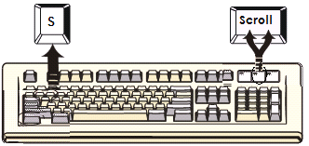

You can activate the Auto-Scan function by using the following two-step Hot Key
sequence. To send commands to the Combo Free KVM Switch, press the [Scroll] key twice (Step 1), then press [S] and then press [Enter] (Step 2). When you press the Auto-Scan hot key sequence, the Combo Free KVM Switch alternates between the two or four PCs and displays them on the monitor.
Each PC is display one of time interval from 5 ~ 250 seconds (The interval is adjustable) before switching to the next. When you press the Auto-Scan Hot Key sequence again, the Auto-Scan will stop and the monitor screen will jump back to the original PC.

Adjustable scan time interval setting ( 5 ~ 250 sec. )

Hot-key: Pressing the <Scroll >, <Scroll > then <S> and <5 ~250 > <Enter>

5.2.3 Beeper Enable
Hot Key:
[Scroll] → [Scroll] → [B] → [Enter] to Disable

[Scroll] → [Scroll] → [B] → [Enter] to Enable
.
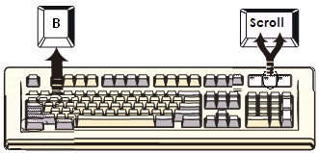

The Speaker/Beeper’s default setting is “Enable”. While the switching connections are activated and Speaker/Beeper is in “Enable” status, the beeper has a short beeping sound.

  - Audio ( Speaker / Microphone ) Selection – only work with Audio version

5.3.1 (PC+Audio) Combination Selection

Hot Key:
[Scroll] → [Scroll] → [ F1 ]→[Enter] or
[Scroll] → [Scroll] → [ F2 ]→[Enter] or

[Scroll] → [Scroll] → [ F3 ]→[Enter] or
[Scroll] → [Scroll] → [ F4 ]→[Enter]
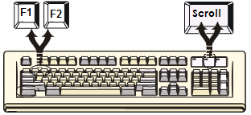

5.3.2 Single Audio ( Speaker + Microphone ) Selection

Hot Key:
[Scroll] → [Scroll] → [A] →[Enter] to enable or disable the audio auto switch mode

[Scroll] → [Scroll] → [A] → [1]→ [Enter] to select PC1 Speaker and Microphone
[Scroll] → [Scroll] → [A] → [2]→ [Enter] to select PC2 Speaker and Microphone
[Scroll] → [Scroll] → [A] → [3]→ [Enter] to select PC3 Speaker and Microphone
[Scroll] → [Scroll] → [A] → [4]→ [Enter] to select PC4 Speaker and Microphone

Note 1: Audio auto switch mode: the default setting of KVM switch is enabled, means when you used the push button, the PCs and Audio will be switched at the same time. In case of the Audio auto switch mode is disabled, then the push button only switch PCs.

Note 2: One long sound – Audio auto switch disabled
Three short sound- Audio auto switch enabled

A

Hot Key definition table
Step 1 | Step 2 | Action
[Scroll] + [Scroll] | [1] + [ Enter ] | Switch the active connection to PC 1
[Scroll] + [Scroll] | [2] + [ Enter ] | Switch the active connection to PC 2
[Scroll] + [Scroll] | [3] + [ Enter ] | Switch the active connection to PC 3
[Scroll] + [Scroll] | [4] + [ Enter ] | Switch the active connection to PC 4
[Scroll] + [Scroll] | [A] + [ Enter ] | Disable or enable the Audio auto switch mode
[Scroll] + [Scroll] | [F1] + [ Enter ] | Combined switching (PC+Audio) to PC 1
[Scroll] + [Scroll] | [F2]+ [ Enter ] | Combined switching (PC+Audio) to PC 2
[Scroll] + [Scroll] | [F3] + [ Enter ] | Combined switching (PC+Audio) to PC 3
[Scroll] + [Scroll] | [F4] + [ Enter ] | Combined switching (PC+Audio) to PC 4
[Scroll] + [Scroll] | [A] + [1] + [ Enter ] | Single switching the active audio to PC 1
[Scroll] + [Scroll] | [A] + [2] + [ Enter ] | Single switching the active audio to PC 2
[Scroll] + [Scroll] | [A] + [3] + [ Enter ] | Single switching the active audio to PC 3
[Scroll] + [Scroll] | [A] + [4] + [ Enter ] | Single switching the active audio to PC 4
[Scroll] + [Scroll] | [B] + [ Enter ] | Disable or enable beeper
[Scroll] + [Scroll] | [S] + [Enter] | Activate the Auto-Scan mode, default 5 sec.
[Scroll] + [Scroll] | [S] + [5 -250 ] +  [ Enter ] | Select the Auto-Scan interval from 5 to 250 Sec.

6. Sun Microsystems Function Key Emulation:

There are 16 special functions on the Sun Microsystems keyboard, the Combo Free KVM Switch can emulate these function keys via the PS/2 and/or USB keyboard. Here is the mapping table for these functions operation. To active these emulation on the PS/2 and/or USB keyboard, you have to press the LEFT Window KEY first (this key usually is located between the left [Ctrl] and left [Alt]), then choice the second relative key.

Sun Micro System Function Key | PS/2 Keyboard
Stop | L_Win & L_Alt
Props | L_Win & L_Ctrl
Compose | L_Win & L_Shift
Front | L_Win & F1
Open | L_Win & F2
Find | L_Win & F3
Again | L_Win & F4
Undo | L_Win & F5
Copy | L_Win & F6
Paste | L_Win & F7
Cut | L_Win & F8
Help | L_Win & F11
Power | L_Win & F12
Mute | L_Win & 1
Volume Down | L_Win & 2
Volume UP | L_Win & 3

Appendix (附錄)
快速使用說明:
1 可設定三種熱鍵切換方式
[Scroll] → [Scroll] → [←] 或 [→]
[Caps] → [Caps] → [←] 或 [→]

2 更改切換方式
[Ctrl] → [Ctrl] → [Caps Lock] → [Enter] : 將熱鍵切換方式改為 [Caps Lock] 模式
[Ctrl] → [Ctrl] → [Num Lock] → [Enter] : 將熱鍵切換方式改為 [Num Lock] 模式
[Ctrl] → [Ctrl] → [Scroll Lock]→ [Enter] : 將熱鍵切換方式改為 [Scroll Lock] 模式

Disclaimer
Information in this document is subject to change without notice. The manufacturer does not make any representations or warranties (implied or otherwise) regarding the accuracy and completeness of this document and shall in no event be liable for any loss of profit or any other commercial damage, including but not limited to special, incidental, consequential, or other damages.

No part of this document may be reproduced or transmitted in any form by any means, electronic or mechanical, including photocopying, recording or information recording and retrieval systems without the express written permission of the manufacturer.

All brand names and product names used in this document are trademarks, or registered trademarks of their respective holders.

FCC Statement
This device generates and uses radio frequency and may cause interference to radio and television reception if not installed and used properly. This has been tested and found to comply with the limits of a Class B computing device in accordance with the specifications in Part 15 of the FCC Rules. These specifications are designed to provide reasonable protection against such interference in a residential installation. However, there is no guarantee that interference will not occur in a particular installation. If this device does cause harmful interference to radio or television reception, which can be determined by plugging the device in and out, the user can try to correct the interference by one or more of the following measures:

- Reorient or relocate the receiving antenna.
- Increase the separation between the device and receiver.
- Connect the computer into an outlet on a circuit different from that to which the receiver is connected.
- Consult the dealer or an experienced radio/TV technician for help.



