

KF08U / KF16U
COMBO FREE
KVM SWITCH

User’s Manual

Version 1.0
Index
1. Introduction….…………………………………………………………………………..3
1.1 Features….……………………………………………………………………………………………...3
1.2 Package Contents….………………………………………………………………………………......3

2. Specifications….………………………………………………………………………...4
2.1 General Specifications….………………………………………………………………………………4

3. System Requirements….………………………………………………………………5

4. Installation….…………………………………………………………………………….5
4.1 Front View….…………………………………………………………………………………………....5
4.2 Rear View….…………………………………………………………………………………………….6
4.3 Single Stage Installation….…………………………………………………………………………….6
4.4 Cascade Chaining….…………………………………………………………………………………...9
4.5 Rack Mounting….……………………………………………………………………………………...12

5. Hotkey Operation….…………………………………………………………...............13
5.1 Call OSD Menu….……………………………………………………………………………............13
5.2 Channel Select….……………………………………………………………………………………..13
5.3 Auto-Scan Function….……………………………………………………………...………………...14
5.4 Buzzer sound Disable / Enable….…………………………………………………………………...14
5.5 Setup Mode….…………………………………………………………………………………….......15
5.6 Cascade Chain Layer Select….……………………………………………………………………...15
5.7 Hot-Key Select….……………………………………………………………………………………...15
5.8 Console Lock….……………………………………………………………………………………….15
5.9 Console unlock….…………………………………………………………………………………......16

6. Sun Micro System Function Key Emulation….……………………………..........16

7. OSD Operation….…………………………………………………………...................17
7.1 OSD Main Menu….……………………………………………………………………………..........17
7.2 Function Control Menu….……………………………………………………………………………17

8. Troubleshooting….…………………………….............................................................25

Appendix (附錄)
Quick Guide (快速使用說明)….………………....................................................................27
1. Introduction
Thank you for your purchase of Combo Free KVM Switch! You now have a high quality, durable system that will enable you to control 8 or 16 Host computers and/or servers by using PS/2 and/or USB Connectors from one console (PS/2 & USB Mouse, PS/2 & USB Keyboard, and Monitor).

  - Features
- Console your Keyboard/Mouse via either way of PS/2 and/or USB arbitrarily.
2. Complex connections with PCs via either way of PS/2 and/or USB arbitrarily.
3. Controls 8 or16 computers from a single console (Keyboard/Mouse) over PS/2 and/or USB connections.
- Supports Windows, Linux, Mac OS9/OSX, Sun Microsystems.
- On-Screen-Display (OSD) & Cascade Chain functions.
- OSD is intuitive menus driven for quick and efficient navigation.
- 3 level cascades: up to 3 levels; control up to 64/256/4096 PCs, from a single console; cascaded units don’t need special configuration.
- Emulates PS/2 or USB keyboard on each PC to allow your computers to boot normally without a keyboard error.
- Supports hot-pluggable. All devices connected to the KVM can be added or removed at any time, without shutting the unit down.
- Supports 3 types of switching:
(1) Hardware Push Button, (2) Hot-Keys on PS/2 and/or USB of keyboard,
(3) Menu driven OSD ( On Screen Display).
- Supports Auto-Scan function to switch video automatically among computers in preset intervals sequentially by OSD menu driven.
- Supports LED display for PC and/or server status monitoring.
- Supports VGA resolutions up to 2048 x 1536
- Supports Beeper during Switching enabled.
- Powered with external power adaptor connection.
- Fully compliant with the USB 1.1/ 2.0 specification.
- Rack Mountable in 19” system tack ( 1U ).

1.2 Package Contents
The product you purchased should contain the following equipment and accessories:
1 x KF08U / KF16U
1 x Rack Mount Kits
1 x DC 5V 2A Power adaptor
1 x User's Manual
2. Specifications

2.1 General Specifications

Specification
Number Of Computers Controlled |  | 8 or 16
Selection Method |  | Push Button and Hot-Key (PS/2 and/or USB Keyboard)  Or On-Screen-Display (OSD)
LEDs |  | Red for PC Selection  Green for PC On-Line ready
PC Connectors | Video | 8 / 16 x HDB-15 female
PC Connectors |  | ( PS/2 & USB signal combined )
Console Ports | Keyboard | 1 x 6 pin mini-DIN female
Console Ports | Mouse | 1 x 6 pin mini-DIN female
Console Ports | Video | 1 x HDB-15 female
Console Ports | Keyboard | 1 x USB – A type female
Console Ports | Mouse | 1 x USB – A type female
Auto-Scan Interval |  | Adjustable time setting by OSD menu driven
DDC, DDC2 monitor |  | Yes ( Max. Resolution up to 2048 x1536 )
Hot Swappable |  | Yes
Operating systems supported |  | Windows 98SE/ME/2000/XP/Vista/2003 Server, Linux
 |  | Mac OS9/OSX and Sun
Device driver |  | No Need
Power |  | By external power adaptor
Dimensions (L X W X H) |  | 44 x 15.7 x 4.5 cm (17.3 x 6.1 x 1.5 inch )
Unit Weight |  | 1750g / 1900 g
Housing material |  | Metal
Operating Temperature |  | 32~ 122°F (0~ 50°C )
Humidity |  | 0%~80%RH

3. System Requirements
Console
A VGA, SVGA, Multisync monitor capable of the highest resolution.
PS/2 and/or USB Keyboard/Mouse

Computer or Server
The following equipment must be equipped with each computer or server.
- A VGA, SVGA or Multisync card.
- Type A USB port or PS/2 6 pin mini-DIN for Keyboard and Mouse.

Cables
The Combo Free KVM Switch must be used specific custom 4-in-1 cables.
To purchase the specific cable sets, please contact your dealer.

4. Installation

4.1 Front View

8-Port
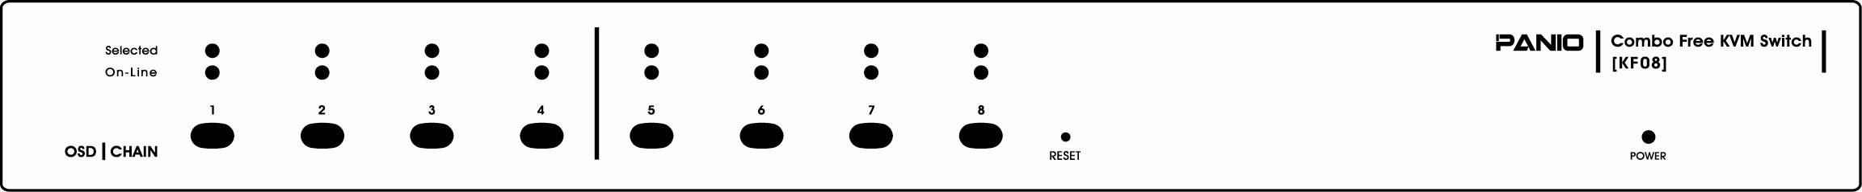

16-Port
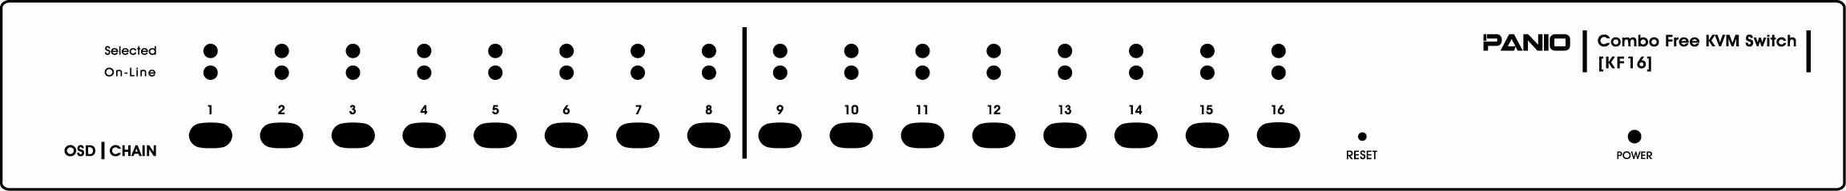

LED Indicators:

Selected : RED LED indicates that the KVM Switch is selected to the corresponding PC.
On-Line : GREEN LED indicates that the KVM Switch is ready to the corresponding PC.

Reset Switch :

Press this switch when a system reset. This switch must be pushed with a thin object, for example, such as the end of a paper clip, or a ball point pen.

4.2 Rear View

8-Port
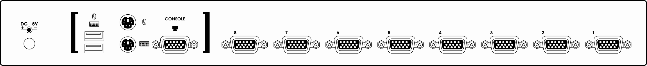

16-Port
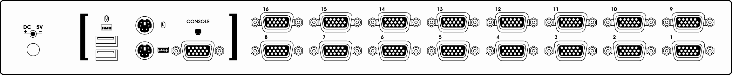

4.3 Single stage installation

Precaution:

1. Make sure all of devices are turning off as connecting up with KVM Switch.
You must unplug the power cords of any computers which might have the Keyboard Power On function in advance. Otherwise, the switch will receive power from the computer.

2. With under running OS Windows 98 , we sugget that the PC must be plugged
to PS/2 ports, because of Windows 98 is not support installation at first time as through USB HID installation driver.

3. There are some of older PCs supported USB ports only, please open
BIOS USB setting in advance.

4. The console plugging is not support USB keyboard of having USB HUB.

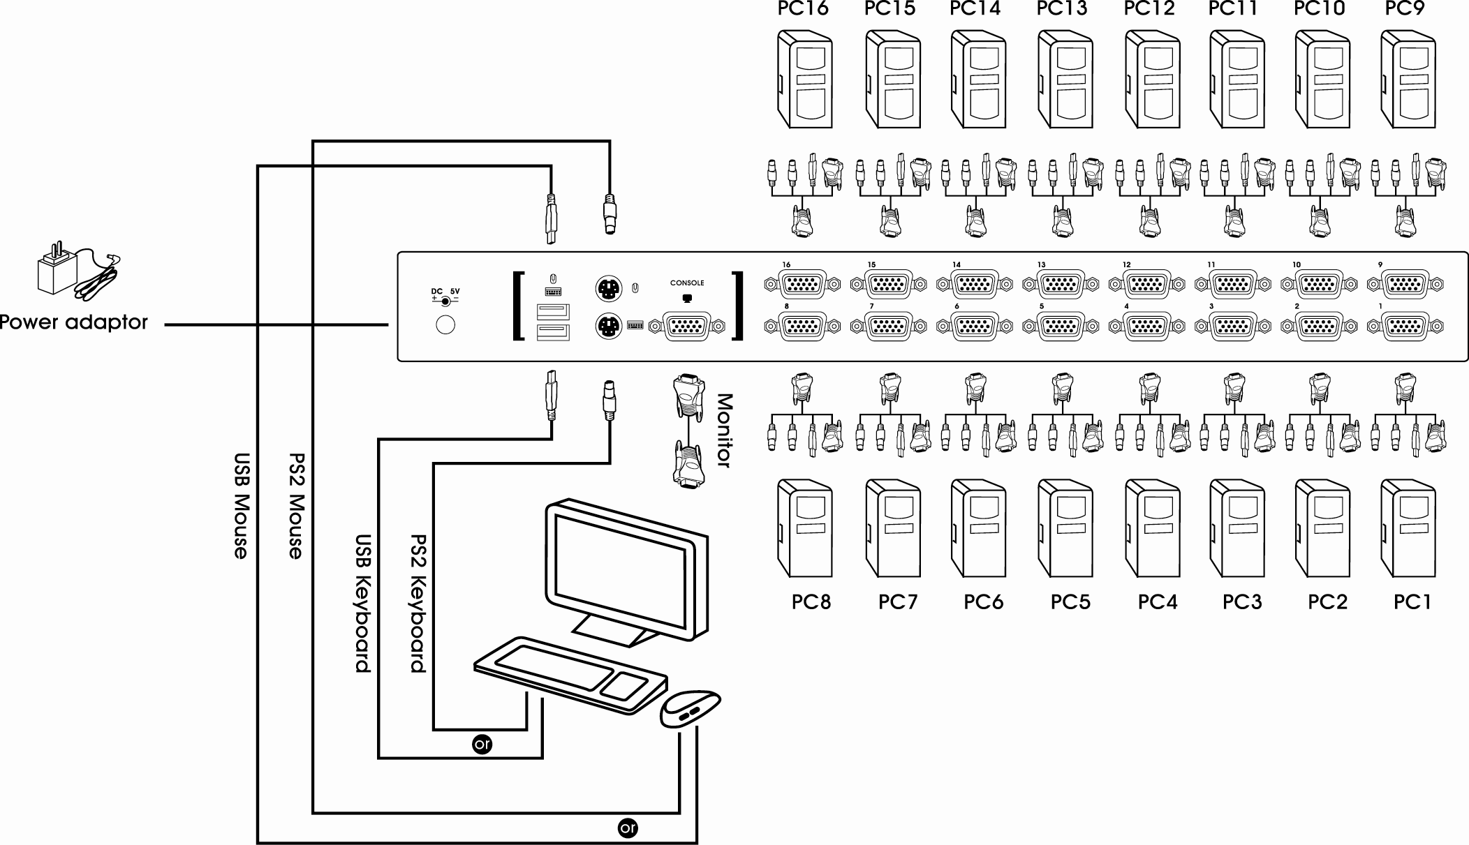

( Fig. 1 )

Console connecting:
Plug either your USB keyboard, mouse or PS/2 keyboard, mouse arbitrarily and VGA video into the Console ports located on the KVM Switch’s rear panel. ( Fig.1)
( Note: No matter what you plugged even thought USB mouse with PS/2 keyboard or PS/2 mouse with USB keyboard are available working to the KVM Switch unit.)

System connecting:
Use KVM custom cable sets to connect any available PC ports to the video and
either USB or PS/2 ports, or even USB & PS/2 all connected of the computers you are connecting up.

( Note: The custome cable set, as Fig. 2, is supplied one cable set with this package; any additional sets is required purchase separately.)
To purchase the custom KVM cable sets, please contact with your dealer.
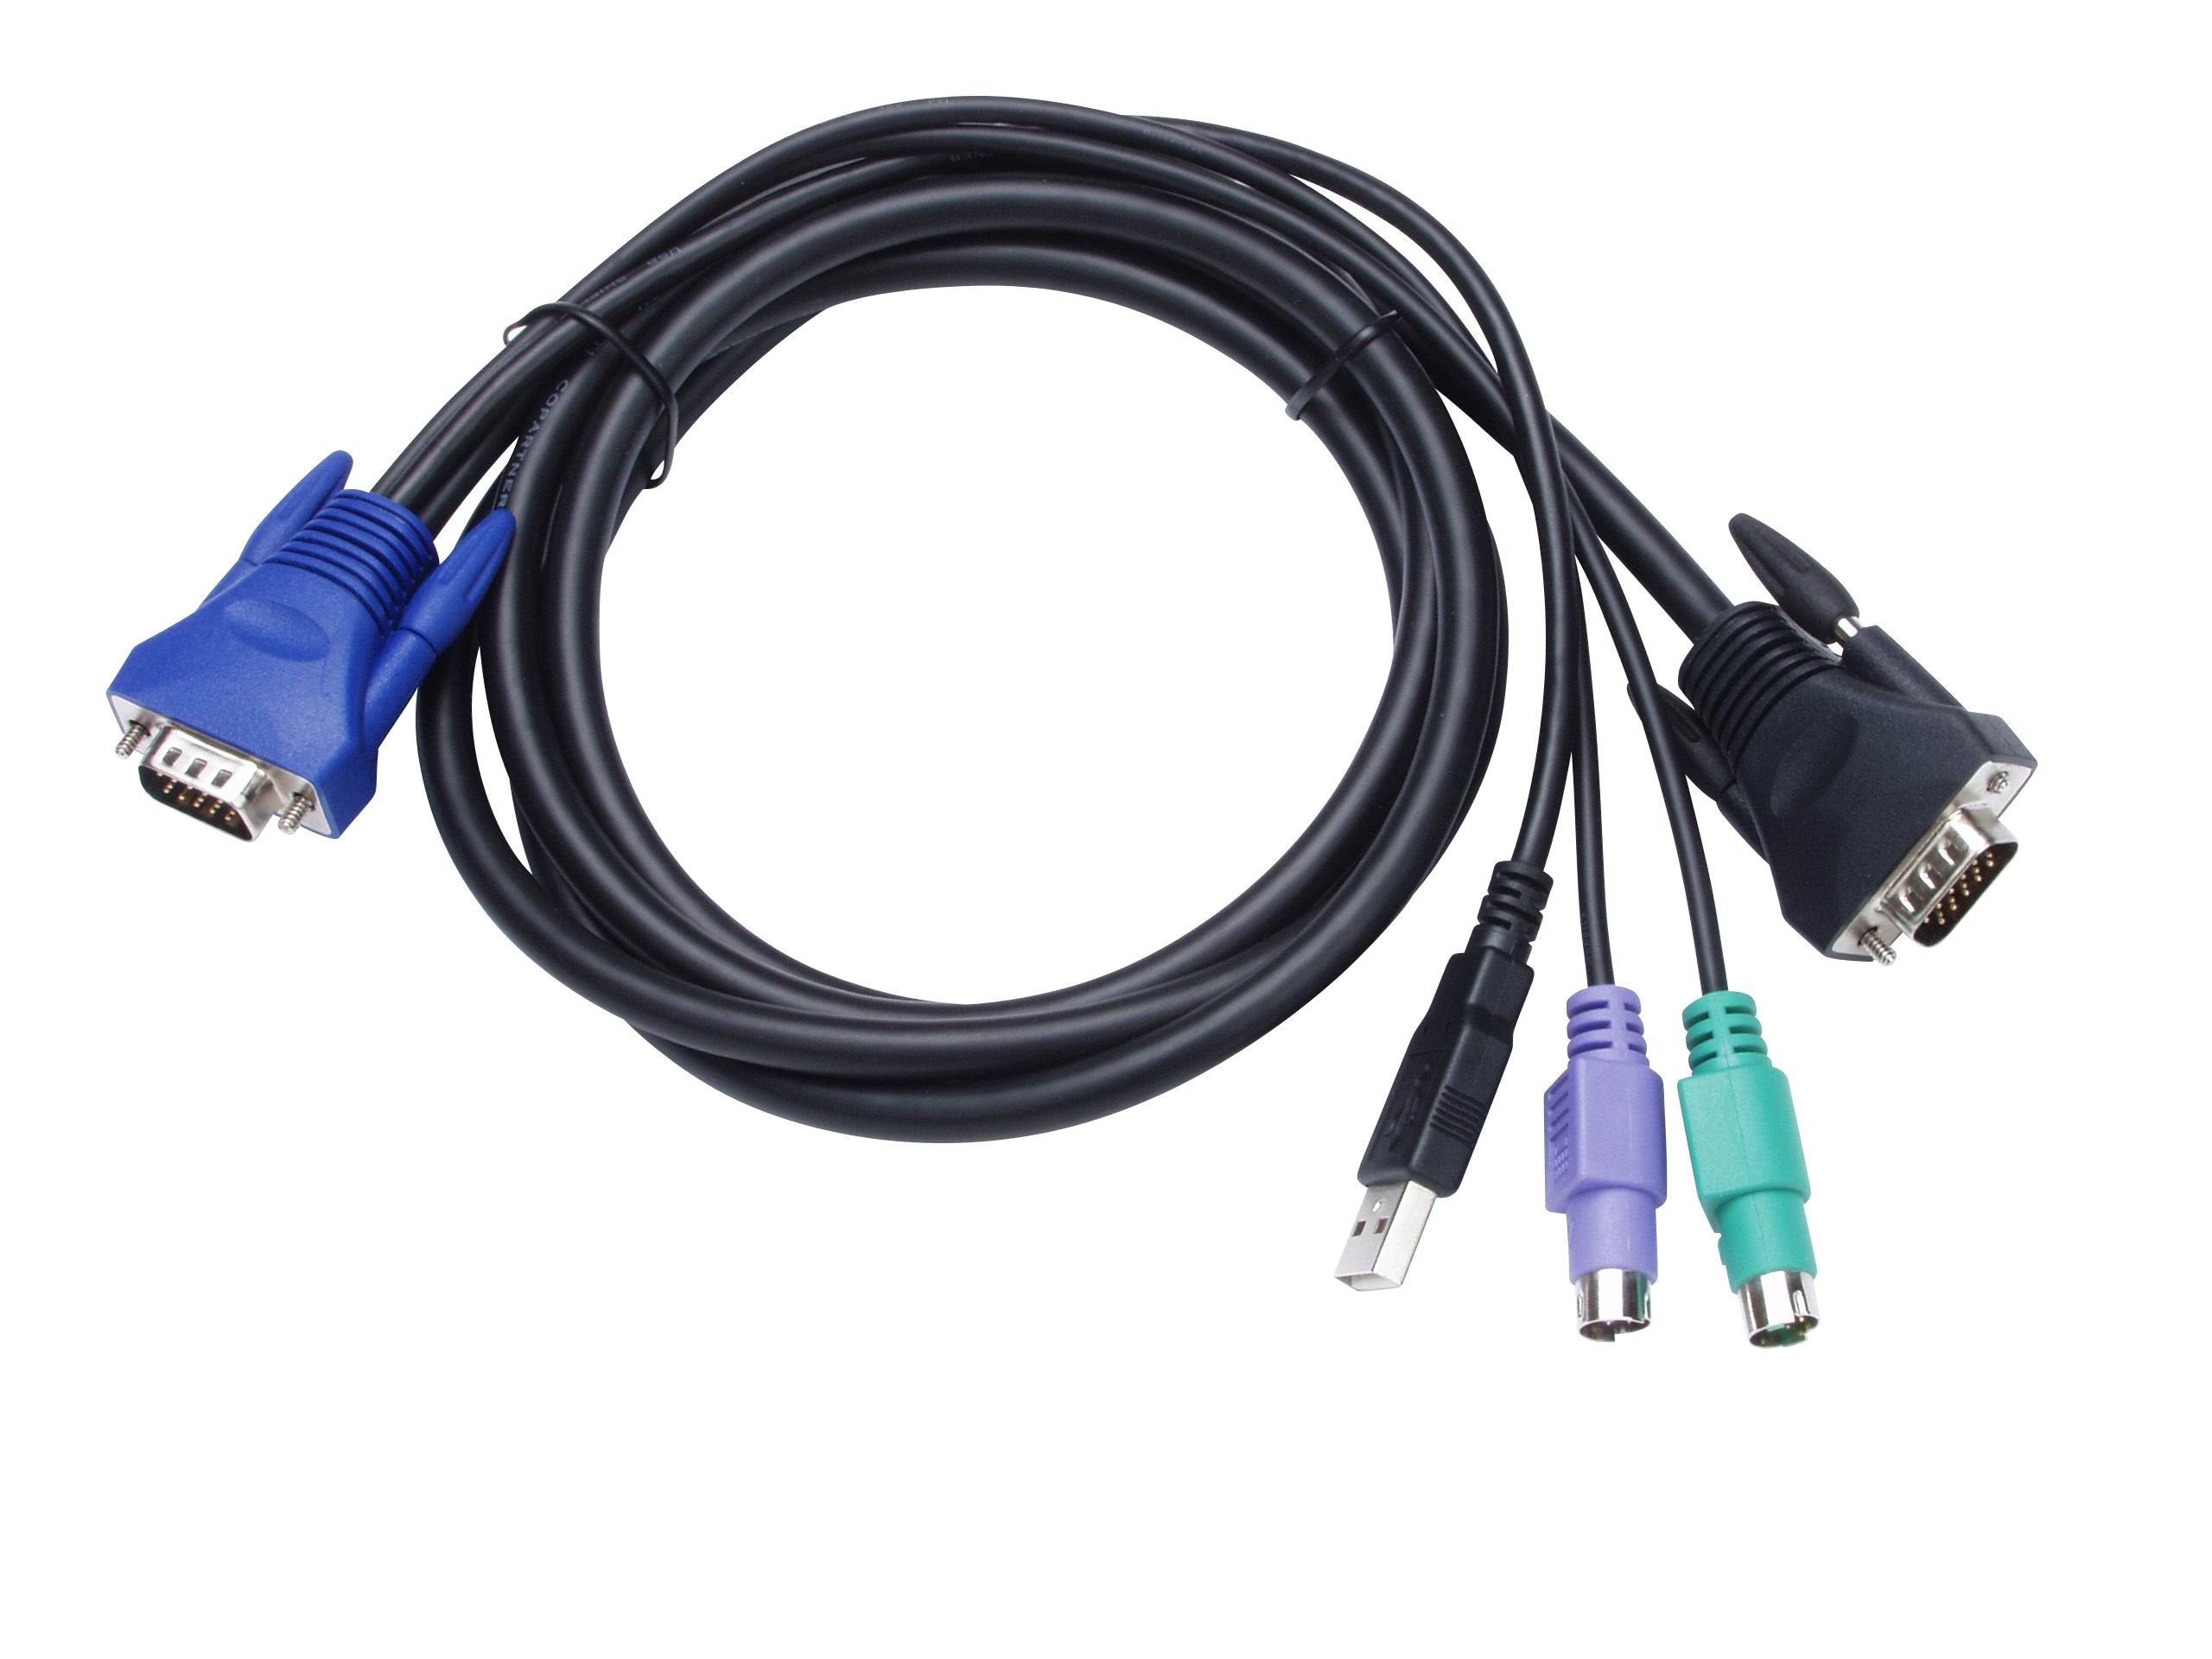( Fig 2 ) custom combo 4-in-1 cable
This KVM Switch with custom specific cable set provide three connectiing methods.
- Plug USB, PS/2 ( keyboard/mouse) ports and VGA video into PCs at same time, recommended in priority. ( Fig. 3 )

( Fig. 3 ) PS/2 & USB and VGA video connected at same time.

- Plug only PS/2 (keyboard / mouse) ports and VGA video into PCs ( Fig. 4 ).

(Fig. 4) PS/2 and VGA video connected.

- Plug only USB and VGA video into PCs. ( Fig. 5 ).

( Fig. 5 ) USB and VGA video connected.

4.4 Cascade Chaining

3 level cascades: up to 3 levels; control up to 64/256/4096 PCs, from a single console; cascaded units don’t need special configuration.

To set up cascade chained installation, please do the following:

- Before you begin install, please make sure all of devices connected must be turned off power before connecting.

- Use the custom cable set ( Fig. 2 ), cascade chain connecting the second and third level of one or more Slave KVM Switches to any PC port of Master KVM Switch. Cascade configuration expands system ability and allows you to select computers connected to the Master or Slave. After connected, KVM Switches automatically configure Master and Slave by themselves.

Note: The second and third level of Slave KVM Switch cascade chained via custome cable set ( see ref. Fig. 2 ) is just only connected their console ports of PS/2 Keyboard, PS/2 mouse and VGA video, no more necessary to connecting USB port.

- All of PC ports of Master KVM Switch and Slave KVM Switches could be support connecting PCs or Servers via through methods ( Fig 3 ),
or ( Fig.4 ) or ( Fig. 5 ).

- You can do console operating your Master KVM Switch via either USB and/or PS/2 keyboard and mouse arbitrarily, even USB mouse with PS/2 keyboard, or PS/2 mouse with USB keyboard both are available to Master KVM Switch.

- Plug in the power adapter for the first level Master KVM Switch and connected PCs, and then plug in power adapter for each level Slave KVM Switch and connected PCs sequently.

- After all of the level of KVM Switches are up, power on the computers.

Initial Power-Up Process:
You must power up the Master KVM Switch first before turning on any other devices.
Note: You may hot plug any powered-down computer and Slave KVM at any time after initial power up process completed.

Hot plug and Hot Swap:
- You can replace keyboard or mouse of the Master KVM CONSOLE port at any time without powering down the Master KVM.
- Plug in or out of PC port or swap PC port could be at any time without powering down th KVM.

(Fig. 6)

4.5 Rack Mounting

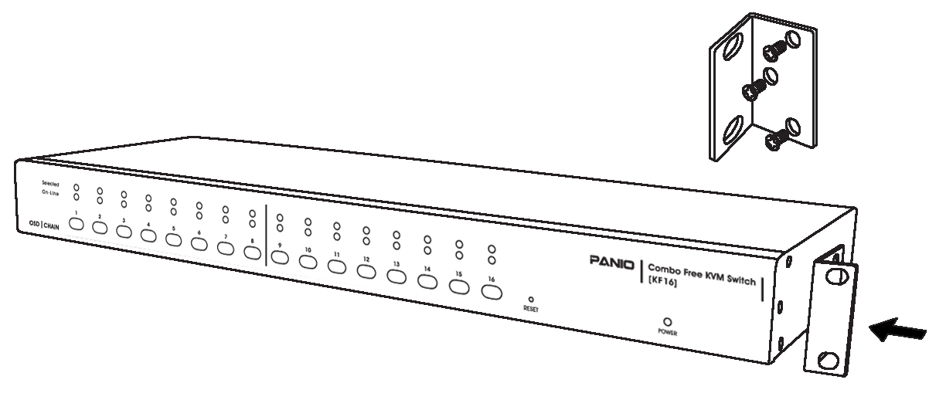

(Fig.7)

Figure 7 shows you how to attach mounting brackets to the KVM Switch unit for standard 19-inch rack cabinet.

- Screw the mounting brackets into the sides of the KVM Switch unit.
- Slide the KVM Switch unit into the rack cabinet and secure it to the rack.

5. Hotkey Operation

The 8-Port or 16-Port Combo Free KVM Switch has the ability to switch the keyboard, video, mouse simultaneously

Note: If your Keyboard is without < Scroll Lock > button, please push <Ctrl> twice, then <K>, and <Enter> to become <Caps Lock> button instead of Scroll Lock.

5.1 Call OSD Menu

Press < Scroll Lock> twice and <Enter>, and then the OSD “ Main Menu”
will be on the screen.
Note: Hot-Key can be changed to become <Caps Lock>. (See page 20 )

5.2 Channel Select ( Single KVM mode )

- OSD: Use Up/Down arrow and <Enter> to select the channel directly.
- Hot-Key via PS/2 and/or USB Keyboard
Press <Scroll Lock> twice, and then Keying a channel number ( 1 to 16 )
And then press <Enter>.
- Left <Alt> or right <Alt> pushed twice, the PC channel will automatically
shift left/right one channel ( channel decrease / increase to next ),
while <Alt> enables.
- <Alt> shift function default was off. You can press Hot-Key <Scroll Lock> twice, <ALT> and then press <Enter> to turn on this function.
[Scroll] → [Scroll] → [ALT] → [Enter]
You can be on/off this function alternately. If buzzer was on, it will generate a beep for correct operating.

Hot Key:

[Scroll] → [Scroll] → [ 1 ] → [Enter] or
[Scroll] → [Scroll] → [ 2 ] → [Enter] or
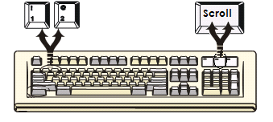
-→ -→ -→ -→
-→ -→ -→ -→
-→ -→ -→ -→
[Scroll] → [Scroll] → [ 16 ] → [Enter]

You can synchronize the PC selection, by using the following two-step Hot Key sequence. To send commands to the Combo Free KVM Switch, press the [Scroll] key twice (Step 1), then press key ( 1 to 16 ) and [Enter] (step 2) to assign the PC to a particular PC. (If you press key [ 1 to 16 ] on the number pad, the keyboard, mouse & video will also be switched synchronously.)

5.3 Auto-Scan Function

- OSD: Call OSD “ Main Menu”, and then press <F2>.
- Hot-Key via PS/2 and/or USB Keyboard
Press <Scroll Lock> twice, <S> and then press <Enter>.

Hot Key:
[Scroll] → [Scroll] → [S] → [Enter] to BEGIN.

Any key pushed will STOP the Auto-Scan operation.
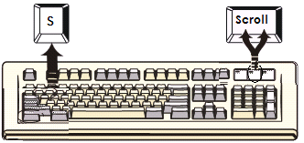

Auto-Scan time interval setting is adjustable via OSD menu operation.

5.4 Buzzer sound Disable / Enable

Hot Key:
[Scroll] → [Scroll] → [B] → [Enter] to Disable

[Scroll] → [Scroll] → [B] → [Enter] to Enable
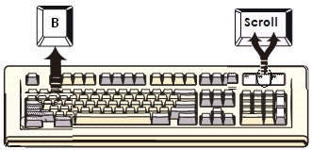
.

The Buzzer sound default setting is “Enable”. While the switching connections are activated and Buzzer sound is in “Enable” status, the beeper has a short beeping sound.

5.5 Setup Mode

- OSD: Call OSD “ Main Menu”, and then press <F1>.
- No Hot-Key operating.

5.6 Cascade Chain Layer Select (Channel Select )

- OSD: Call OSD “ Main Menu”, select channel and then press <Enter>
layer by layer.
- Hot-Key via PS/2 and/or USB Keyboard
Press <Scroll Lock> twice, <D>, number (1,2,3……16), and Press <Enter>.

Note: With cascading 3 layers, you can select last layer directly;
Example : press <Scroll Lock> twice, then D2D5D7, and <Enter>:
D2 : layer 1 channel 2 links to
D5 : layer 2 channel 5 links to
D7 : layer 3 channel 7 selected

5.7 Hot-Key Select

- OSD: Call OSD “ Main Menu”, and then press <F1>, and then select Hot-Key change.
- Hot-Key via PS/2 and/or USB Keyboard
Press current Hot-Key twice, <K> and then press <Enter>.
The Hot-Key will change to another one.( <Scroll Lock> or <Caps Lock>).

5.8 Console Lock

- OSD: Call OSD “ Main Menu”, and then press <F3>
( <F5>: Security mode must be turn on first.)
- Hot-Key via PS/2 and/or USB Keyboard
Press <Scroll Lock> twice, <H>, and Press <Enter>.
5.9 Console unlock

- OSD: Display the message only.
- Hot-Key via PS/2 and/or USB Keyboard
Press any key into the Unlock window, and then enter the correct User Name and Password. KVM and console device will unlock and be back to normal operation.
6. Sun Microsystems Function Key Emulation:
There are 16 special functions on the Sun Microsystems keyboard, the Combo Free KVM Switch can emulate these function keys via the PS/2 and/or USB keyboard. Here is the mapping table for these functions operation. To active these emulation on the PS/2 and/or USB keyboard, you have to press the LEFT Window KEY first (this key usually is located between the left [Ctrl] and left [Alt]), do not release the lift Window key choice the second relative key, and then release the two keys.

Sun Microsystems Function Key | USB or PS/2 Keyboard
Stop | L_Win & L_Alt
Props | L_Win & L_Ctrl
Compose | L_Win & L_Shift
Front | L_Win & F1
Open | L_Win & F2
Find | L_Win & F3
Again | L_Win & F4
Undo | L_Win & F5
Copy | L_Win & F6
Paste | L_Win & F7
Cut | L_Win & F8
Help | L_Win & F11
Power | L_Win & F12
Mute | L_Win & 1
Volume Down | L_Win & 2
Volume UP | L_Win & 3

7. OSD Operation

OSD (On-Screen-Display) Operation

- OSD Main Menu for Administrator

1 2 3 4
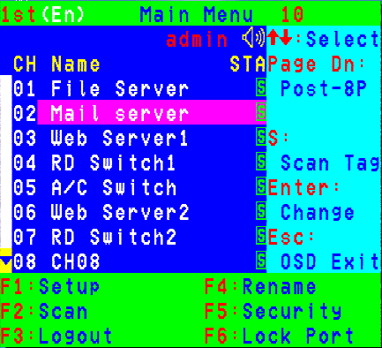
6

5

Figure 8: Administrator OSD
s
s

  - OSD Main Menu
    - KVM layer number: 1st, 2nd, 3rd
    - PC name (defined by user): 31 characters (Max.)
    - PC Status: (Status: STA, See above figure 8)

 Buzzer sound on
 Buzzer sound off
L Locked port indication, and normal is blank
 Indicating the computer is powered on
s Indicating the channel scan function is on

    - Current channel number

- Cascade channel number: only display cascade 2nd, 3rd layer connected channel number; if it’s in 1st layer, it will show blank.

- Page down-up indicator: (to next page) while connecting 16 port OSD KVM, it will show up & down arrows alternatively to select previous/next page’s port number. (Only for 16-port KVM only.)

  - Function Control Menu
F1: Set up: basic set up menu
F2: Scan: autoscan function
F3: Lock: setup lock/unlock, and available when F5 Security is set ‘ON’
F4: Rename: rename selected port name.
F5: Security: security function and user priority setting
F6: Lock Port: PC port lock function (administrator only)

- OSD Main Menu for Other User (1, 2, 3)

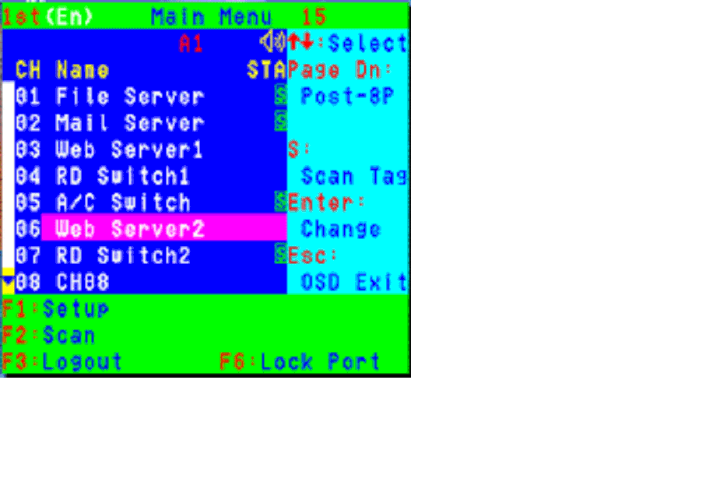

Figure 9 : User OSD

By pressing <Scroll Lock> twice and <Enter>, you will see an OSD 'Main Menu' popped out in the screen with channel number, names and other status and other function keys, please see figure 8 above. The channel of the currently selected computer is displayed in the top right corner and a highlighted pink bar shown in the selected channel row. The sign  is displayed if computer has power on and ready for being selected (its corresponding front panel indicator is green). If it doesn’t appear ¿ sign, it means no computer connected or no powered up. OSD menu will update the sign ¿ when computer is activated. Use the <UP> and <DOWN> arrow keys to highlight a computer and the <ENTER> to select it and leave OSD menu. Or, you can press <ESC> to exit OSD menu.

A plus mark (+) showing in the left of a name indicates that the port has cascades. The number at the up-left corner (below KVM layer number) shows the number of port for the upper layer, i.e. 8 means link from upper KVM 8. If in master layer it will show blank. <ENTER> brings you one level down and the screen pops up listing the names of the computers on the Slave KVM. The name of the Slave will be shown at the OSD menu. It is useful to group computers and still be able to see the group name. Press <R> will return to upper layer OSD menu. Press <ESC> to exit OSD and to return to the selected computer; the computer name is also shown on the screen with a left-up banner.

● F1: Setup Mode

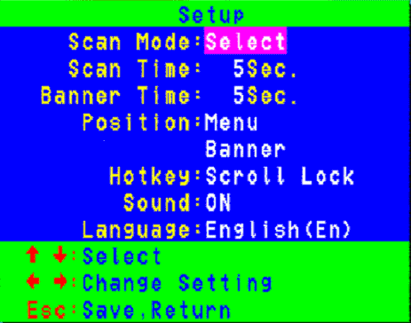
Figure 10: OSD Setup

All changes are enabled by left/right arrow key (← →) to select it.
■Scan Mode: Select – Scan selected channels in ‘STA’ column with ‘s’ on OSD main menu.
PC ON – Scan all powered-on PC channels only.
■Scan Time: 5 sec(Default) to 90 sec., 5 sec. a select step
■Banner Display Time: 5 sec. (Default), 10 sec., 15 sec, and always on (∞).
■Display Position: Menu – use four arrow keys to move the OSD main menu to the desired position.
Banner – use four arrow keys to move the channel banner to the desired position.
  - Hot-Key: Scroll Lock – Scroll Lock becomes the Hot-Key.
Caps Lock – Caps Lock becomes the Hot-Key.
Ctrl – Ctrl is a defaulted Hot-Key.

Note: Scroll and Caps Lock are alternative. While Scroll Lock is enabled, if you want to alter the Hot-Key to Caps Lock, you just press ‘Scroll Lock’ twice, K, and <enter>, and vice versa.

  - Sound: ON – Buzzer sound enabled. (Turn on)
OFF – Buzzer sound disabled. (Turn off)
  - Language: English (En) / Deutsch (De) / Francais (Fr), 3 languages.

- Position Adjustment

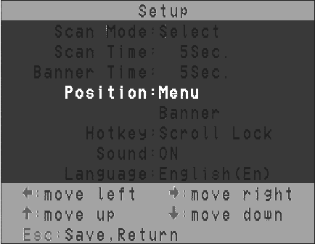
Figure 11: Select Items to Setup

Into the banner Display Position, the display will become:

- Channel Banner ( Single Layer ) (Max. 22 characters)
┬ ────┬──────
│ └PC (Channel) Name
└───────────── Channel (PC) Number
- PC powers on or change channel by OSD/Hot-Key, this banner will display 5 sec, and disappear. User can change display time in the Setup Mode (F1).

- Channel Banner ( Multi-Layer ) (Max. 22 characters)
┬ ┬ ┬ ────┬──────
│ │ │ └ PC (Channel) Name
│ │ └─────── Channel (PC) Number
│ └─────── 2nd Layer Channel (PC) Number
└───────────1st Layer Channel (PC) Number
- PC powers on or changes channel by OSD/Hot-Key, this banner will display 5sec., and disappear. User can change display time in the Setup Mode (F1).

- Channel Banner (Scan Mode)
─┬── ┬ ──┬──────
│ │ └─PC (Channel) Name
│ └──────── Channel (PC) Number
└───────────── Scan Mode
  - Stop scan: press any key.
  - Banner will disappear when the scan stops.

- F4: Rename (New Name: 31 characters Max)
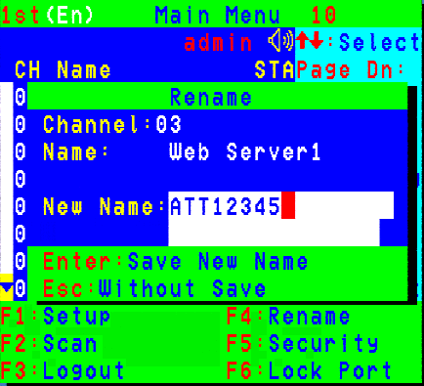
Figure 12: F4 Function Setup

- F5: Security Mode
Entry Password:
(Default User Name: admin, Password: 123456)
After entering correct password, Security function is enabled.

Figure 13: Security Function Setup (1)

After the Security mode is ‘ON’ status, and F3 Lock Mode will be enabled automatically (it will display on the Main Menu).
Also the Hot-Key Lock function (H) will be available.

After security mode is on, you can actively lock Hot-Key function (F3 or <H> Hot-Key), until keyin a password, the console will be locked as log-out status. (Hot-Key twice, <H>, and <Enter>) Only administrator can keyin password to unlock the console, but according to the limit of authority setting, different user will have different access computers.

- Change Administrator Password:
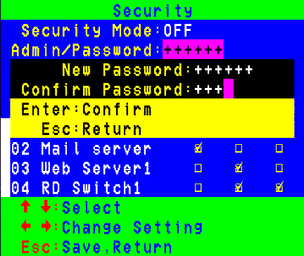
Figure14: Security Function Setup (2)

● Change User Name and Password:
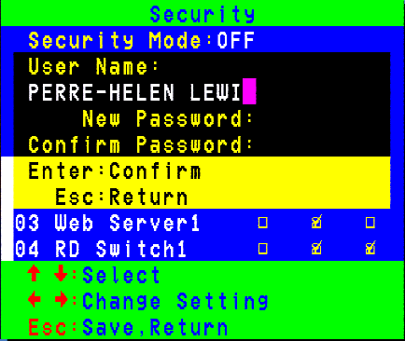
Figure15: Security Function Setup (3)
● User PC Channel Authorization Setting
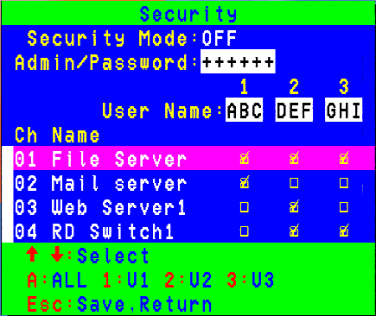
● F6 Lock Port
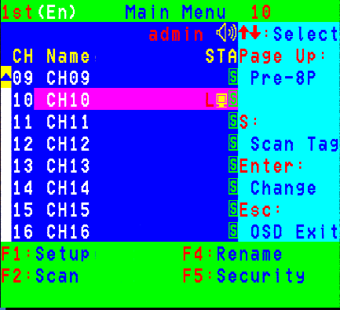
Figure16-17: Security Function Setup (4-5)
After PC port locked, “L” mark will show in its STA column until unlock status. (Select F6 and keyin password again, and the PC port unlocks.)

- F3 Console Lock Mode Banner:
Into the Security lock mode, this banner will display until Unlock status. The console device and KVM button will lock (no any function could be enabled while back to unlock status); the keyboard will just accept the correct password only. (Press any key into the unlock window.)


- Unlock Window:

After key in a correct User Name and Password, the system will unlock (leave the Security mode), screen will be into the normal and all devices are available to operate (according to the authorization setting).

Note: If you forget the password, the only way to permanently disable the security function is to key in a universal password to unlock KVM. You need to key in this unlock password to release your device and KVM, and then you can restart everything.

Universal password will let your KVM go back to defaulted administrator password, ask the Universal password to your agency/distributor.

8. Troubleshooting :

Symptom | Possible Cause | Recommended Solution
Keyboard and/or Mouse not working. | Keyboard and/or Mouse need to be reset | To unplug from console port(s), and then replug  it / them into console in.
Keyboard and/or Mouse not working. | Failed connection to the computer. | Check the cable connected from switch to computer and make sure it is connected properly.
Keyboard and/or Mouse not working. | KVM Switch needs to be reset | Power off all of devices and then power up again.
Master/ Slave daisy chained doesn’t work | Incorrect configuration or improper installation procedures | Make sure the console of the Slave’s connected to Master’s PC port.  Remove any possible power supplies to the slave ( unplug all cables), before connecting it to the Master.
Double OSD images at cascade configuration | Improper slave connection procedure.  Fail connection | Remove any possible power supplies to the Slave ( unplug all cables), before connecting it to the Master.  Make sure cable is connected well, Slave console link to Master port.
OSD menu is not at the proper position | OSD menu has fixed resolution and its size varies due to the changes of computer VGA resolution | Use <F1>: Set/Position to move OSD menu and banner to proper position.

Disclaimer
Information in this document is subject to change without notice. The manufacturer does not make any representations or warranties (implied or otherwise) regarding the accuracy and completeness of this document and shall in no event be liable for any loss of profit or any other commercial damage, including but not limited to special, incidental, consequential, or other damages.

No part of this document may be reproduced or transmitted in any form by any means, electronic or mechanical, including photocopying, recording or information recording and retrieval systems without the express written permission of the manufacturer.

All brand names and product names used in this document are trademarks, or registered trademarks of their respective holders.

FCC Statement
This device generates and uses radio frequency and may cause interference to radio and television reception if not installed and used properly. This has been tested and found to comply with the limits of a Class B computing device in accordance with the specifications in Part 15 of the FCC Rules. These specifications are designed to provide reasonable protection against such interference in a residential installation. However, there is no guarantee that interference will not occur in a particular installation. If this device does cause harmful interference to radio or television reception, which can be determined by plugging the device in and out, the user can try to correct the interference by one or more of the following measures:

- Reorient or relocate the receiving antenna.
- Increase the separation between the device and receiver.
- Connect the computer into an outlet on a circuit different from that to which the receiver is connected.
- Consult the dealer or an experienced radio/TV technician for help.



Appendix (附錄)
快速使用說明:
1 顯示OSD選單
按< Scroll Lock >鍵兩次，接著按<Enter>鍵，OSD主選單就會顯示在螢幕上
註：熱鍵可以改變為<Caps Lock>鍵(參考第20頁)

2 頻道選擇(單一電腦切換器KVM模式)
● OSD : 使用上/下鍵，接著按<Enter>鍵直接選擇頻道
● 熱鍵支援PS/2或USB介面鍵盤滑鼠
按<Scroll Lock>鍵兩次，輸入頻道號碼(1~16)，接著按<Enter>鍵
● 左邊<Alt>鍵或是右邊<Alt>鍵按兩次，當使用<Alt>鍵，電腦頻道會自動轉換成左/右的頻道(頻道加減至下一個)
● 當<Alt>鍵轉換功能隱含值關閉時，按快速鍵<Alt>鍵兩次，接著按<Enter>鍵
可以選擇性的開/關此功能。假設系統警報器有開，將會出現嗶嗶的聲音來修正操作

如熱鍵切換方式：
[Scroll]→[Scroll]→[1]→[Enter]或
[Scroll]→[Scroll]→[2]→[Enter]或
[Scroll]→[Scroll]→[16]→[Enter]

使用以上先後的熱鍵步驟，可以選擇同步PC畫面以及聲音。當傳送命令至Combo Free控制端雙介面電腦切換器KVM，第一步驟按[Scroll]鍵兩次，第二步驟按數字鍵(1~16)，接著按[Enter]鍵分配PC到特定的PC。
(假設在數字鍵按1~16，鍵盤、滑鼠及影音將會同步切換。)

3自動掃描功能
● OSD : 顯示OSD主選單，按<F2>鍵
● 熱鍵支援PS/2或USB介面鍵盤滑鼠
按<Scroll Lock>鍵兩次，接著按<S>鍵，再按<Enter>鍵

熱鍵：
[Scroll]→[Scroll]→[S]→[Enter]開始掃描功能
碰觸任一鍵將會終止自動掃描功能.
自動掃描時間間隔設定可以透過OSD選單操作調整.

4系統警報器聲音關閉/使用

熱鍵：
[Scroll]→[Scroll]→[B]→[Enter]關閉系統警報器
[Scroll]→[Scroll]→[B]→[Enter]使用系統警報器
當切換連結進行中，系統警報器聲音設定值在”使用”。當系統警報器在”使用”的狀況下，會出現短暫的嗶嗶聲。

5設定模式
● OSD：顯示OSD主選單，按<F1>
● 無熱鍵操作

6串聯鏈層選擇(頻道選擇)
● OSD：顯示OSD”主選單”，選擇頻道，接著一層一層的按<Enter>鍵
● 熱鍵支援PS/2或USB介面鍵盤滑鼠
按<Scroll Lock>鍵兩次，按<D>鍵，數字(1,2,3….16)，接著按<Enter>r鍵

註：當串聯至3層時，可直接選擇最後一層
例：按<Scroll Lock>鍵兩次，接著D2D5D7，按<Enter>鍵
D2：第一層頻道2連結
D5：第二層頻道5連結
D7：第三層頻道7選擇

7熱鍵選擇
● OSD：顯示OSD”主選單”，接著按<F1>鍵，選擇熱鍵切換
● 熱鍵支援PS/2或USB介面鍵盤滑鼠
按目前的熱鍵兩次，<K>鍵，接著按<Enter>鍵
熱鍵將會切換至另一個(<Scroll Lock>或是<Caps Lock>)

8控制端鎖定
● OSD：顯示OSD主選單，接著按<F3>(<F5：安全模式必須先開啟>)
熱鍵支援PS/2或USB介面鍵盤滑鼠
按<Scroll Lock>鍵兩次，<H>鍵，接著按<Eneter>鍵

9控制端開啟
● OSD：只顯示訊息
● 熱鍵支援PS/2或USB介面鍵盤滑鼠
按任一鍵進入Windows開啟模式，接著進入正確的使用者名稱及密碼
KVM及控制端將會開啟並且會回到正常的正常操作

