1-Port / 4-Port / 8-Port
VGA/Audio Extender
Transmitter over Cat.5
( Video & Audio )

User’s Manual

VAE-331T ( Transmitter )
VAE-334T ( Transmitter )
VAE-338T ( Transmitter )
VAE-331R ( Remote Receiver )

Version 1.1

Index
1.
Introduction……………………………………………………………………………………………2
1.1 Features …………………….…..………………………………….………………………… ………2
1.2 Package Contents…………………………………...……………..………………………………..2
2. Specifications……………………………………………………………………….…………………3
2.1 General…………………………………..………………………...………………..…………………3
3. Connecting vga/audio extender transmitters over cat.5…..….…………………4
3.1 transmitters installation………….……………………………………………..……………….4
3.2 VAE-331R receiver installation………………............……………..………….…………………6
4. VAE-331R remote Receiver operation (optional)………………..…..….…………………7

- Introduction

Thanks for your purchasing the 1-Port / 4-Port / 8-Port VGA/Audio Extender Transmitter over Cat.5. We recommend that you read this manual thoroughly and retain for future reference.

  - Features

The 1-Port / 4-Port / 8-Port VGA/Audio Extender Transmitter over Cat.5
allows you to extend source computer’s video and audio upon maximum 330 meter distance to one monitor or projector. With the built-in video and audio signals enhancement, you can gain the best video resolution quality and audio stereo sound comfy with listening. No software is required and furthermore the installation and operation are easily more than expected. From use in extension bench facilities of video and audio, this product, 1-Port / 4-Port / 8-Port VGA/Audio Extender Transmitter over Cat.5, delivers both performance and value.

- Supports Stereo Digital Audio (2CH) with premium sound performance.
- Uses economical, reliable Category 5 Ethernet cable to connect the local and remote units.
- Long distance transmission up to 330 meters.
- Extra local ports to monitor remote unit.
- Supports cascadable chaining via through local ports to expand distribution ports
- Supports VGA, SVGA, XGA, SXGA and Multisync monitors.
- Easy installation
- Comply with Windows, LINUX, Mac OS 8.6/9/10 and SUN Solaris.

  - Package Contents

- 1-Port or 4-Port or 8-Port VGA/Audio Extender Transmitter over Cat.5 x 1
- Power Adaptor DC 5V x 1
- Video VGA ( Male – Female ) cable 1.8 meter x 1
- Audio ( Male- Male ) cable 1.8 meter x 1
- User’s Manual x 1

2. Specifications

2.1 General

Specification
Model Number | ( Transmitter * 1 / *4 / *8 )
Video Signal Type | D-SUB 15 PIN
Audio Signal Type | 2CH Stereo Audio
Connection Type | Cable for CAT5/ 5e / 6
Tx Bandwidth | 350Mhz -3dB @ 1200V/us
Video Input Level | Typical +-0.75Vrms
Max. Resolution /  Effective Distance | 1920 x 1200 – 75 m  1600 x 1200 – 100 m  1400 x 900 – 150 m  1280 x 1024 – 250 m  1024 x 768 – 300 m  800 x 600 – 330 m
Max Distance | 330 Meter
Digital Audio Sample Rate | 32Khz 24Bits@256fs
Audio Input Impedance(Tx) | 10K Ohm
Audio Input Level(Tx) | 2Vrms (line level)
Local VGA Out | 1 VIDEO PORT.
Local Stereo Speaker Out | 1 AUDIO PORT.
Cascade ability | Yes
Power Consumed | 650mA
Power Source | POWER ADAPTOR DC5V,

3. Connecting VGA/Audio Extender Transmitter over Cat.5

3.1 VAE-331T/VAE-334T/VAE-338T Transmitter Installation

- UTP Cable connected with Transmitter, in order to get the best display quality, please use Cat.5e or above Cable, and the cable connector is to connect to Transmitter output port ( RJ45 connector )

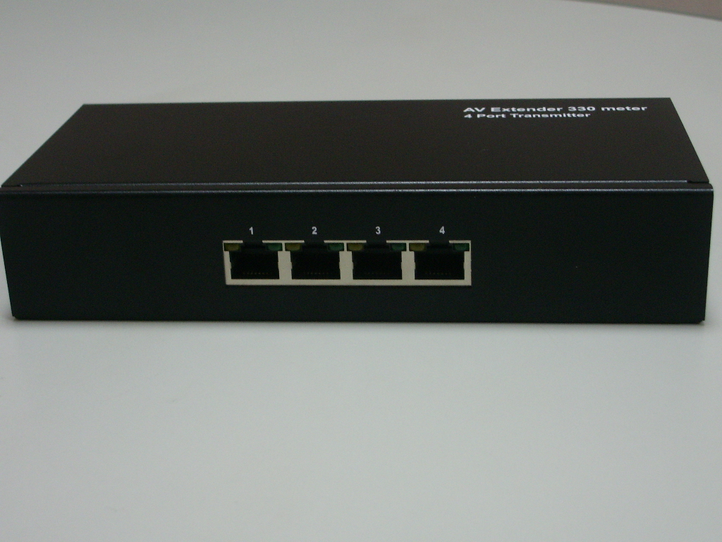

UTP cable connected RJ45 connector

- PC connected with Extender Transmitter:
  - Connects Transmitter VGA IN with VGA cable to VGA port of PC.
  - Connects Transmitter AUDIO IN to the Speaker Output Port of PC.
  - Connects Transmitter with external power adaptor DC5V.
  - VGA cable ( Male – Female ) 1.8 meter
  - Audio Stereo cable ( Male-Male ) 1.8 meter

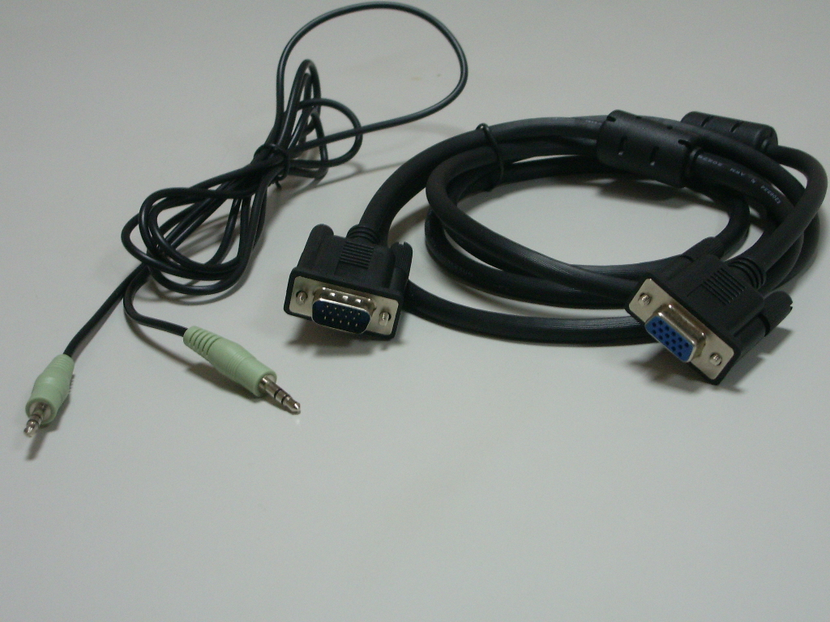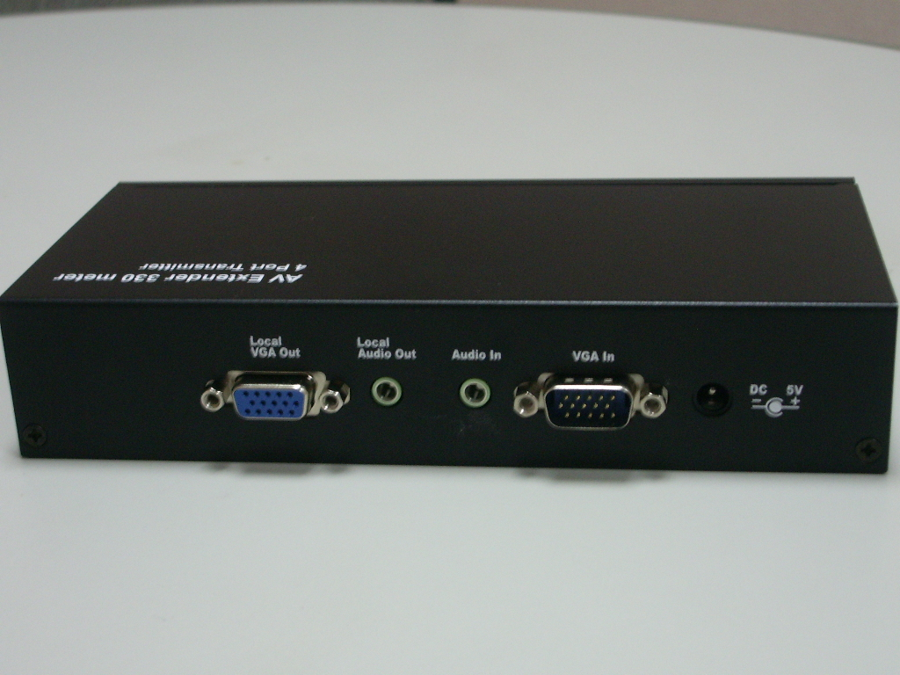
c.
e. d. b.
a.

- Cascadable Chain Connection
1-Port or 4-Port or 8-Port VGA Extender Transmitters could be done cascadable chaining to expand RJ45 ports distributing Video & Audio signals to receiver remote units.

Local VGA Out → VGA IN ( Cascade Chain another Transmitter )

Local AUDIO Out → AUDIO IN ( Cascade Chain another Transmitter )

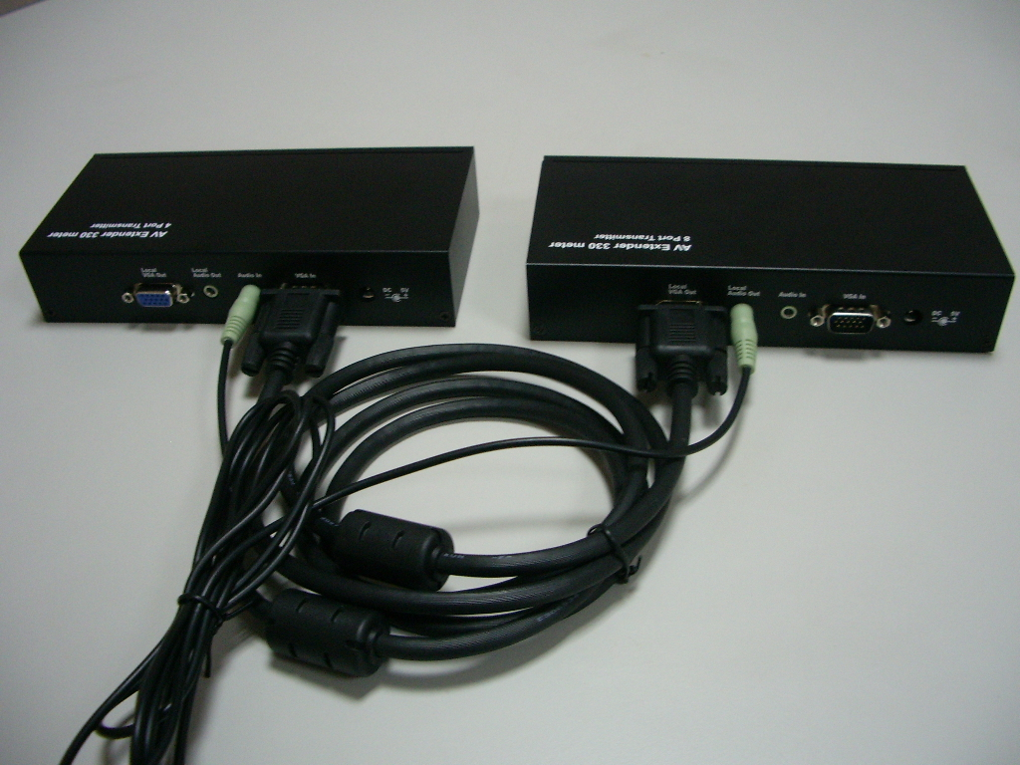

  - VAE-331R Remote Receiver Installation ( optional )
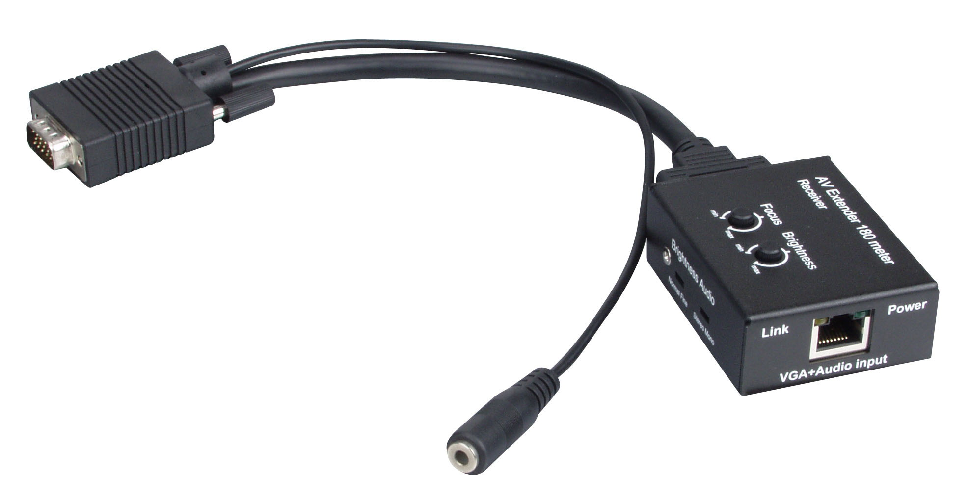

- UTP Cable connected with Receiver (VAE-331R), in order to get the best display quality, please use Cat.5e Cable, and the cable connector is to connect to
Receiver VGA + Audio input port ( RJ45 )
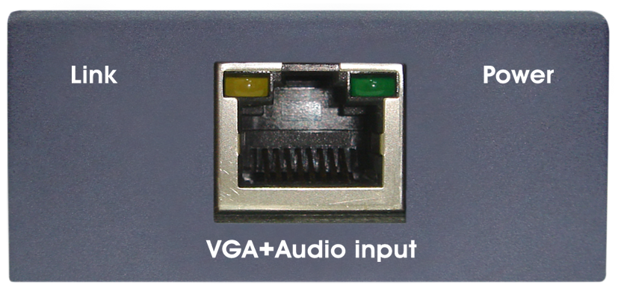
CAT5e Cable Connected

- Monitor Connection:
Connects Receiver VAE-331R VGA cable connector and screwed tightly to
VGA port of PC.
- Speaker Connection:
Connects the Speaker Stereo Plug to the Audio Stereo Jack of VAE-331R.

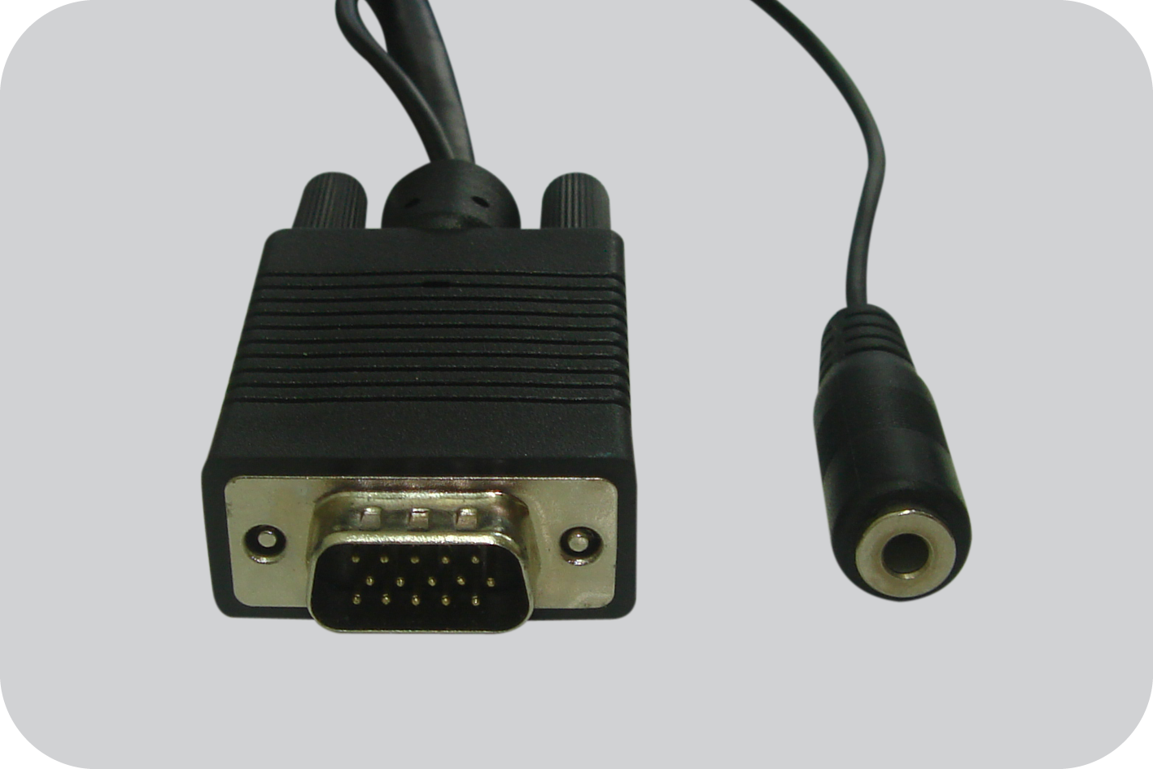
LCD Monitor VGA Port Connected
LCD Monitor Speaker Port Connected connected

- The Power Adaptor plugs to VAE-331R Power Jack ( DC 5V ).

- Operation ( VAE-331R Remote Receiver )

  - TEST FUNCTION:

    - PC POWER ON: Turn on PC power, and access PC into OS.
( If the monitor screen shown “ Out Of Range” or black, which means the resolution setting is not compliant with monitor, please adjust down PC resolution.)
    - MUSIC PLAY: Open music files, then play music, ensure external speaker is
working as well.

  - ADJUSTMENT:

    - VIDEO ADJUSTMENT:

BRIGHTNESS SWITCH:
- Normal State :
The normal state is suggested to use the Cat.5e cable length below 100 meter.
- Fine State :
The fine state is suitable for Cat.5e cable length over 100 meter, but if the screen is too bright interrupting seeing, please reverse switching to normal state.

AUDIO SWITCH:
- Stereo State : Stereo 2.1 Channel Sound

- Mono State : Normal Sound

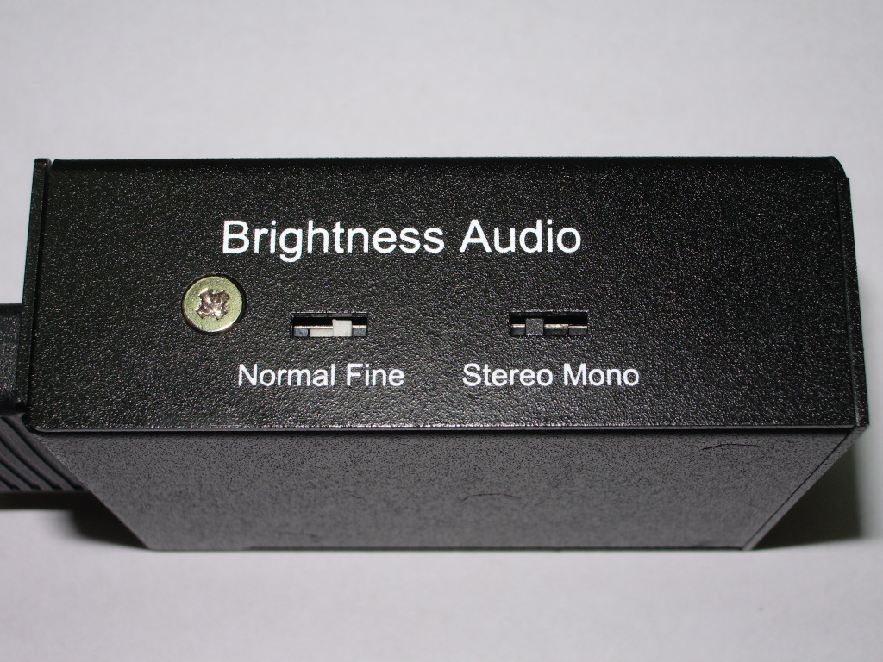
Brightness Switch
Audio Switch

    - Brightness VR: Brightness Tuner

- If the screen felt too dark, to increase tuning Brightness level.
( In case of non-working increasing brightness even tune Brightness VR upto Max. , please adjust Brightness Switch to Fine State, then restart tuning Brightness VR again.
- The screen is feeling too much bright, please try tune down Brightness VR level.

    - Focus VR: Focus Tuner

- If the screen is feeling misty, please tune Focus VR up to proper level.
- If the screen is obviously shown tailing images, then try to tune down VR level.
( Sometimes, to increase brightness lightly will be also working.)

VAE-331R ( Remote Reveiver )
Focus Turner
Brightness Tuner

Disclaimer
Information in this document is subject to change without notice. The manufacturer does not make any representations or warranties (implied or otherwise) regarding the accuracy and completeness of this document and shall in no event be liable for any loss of profit or any other commercial damage, including but not limited to special, incidental, consequential, or other damages.

No part of this document may be reproduced or transmitted in any form by any means, electronic or mechanical, including photocopying, recording or information recording and retrieval systems without the express written permission of the manufacturer.

All brand names and product names used in this document are trademarks, or registered trademarks of their respective holders.

FCC Statement
This device generates and uses radio frequency and may cause interference to radio and television reception if not installed and used properly. This has been tested and found to comply with the limits of a Class B computing device in accordance with the specifications in Part 15 of the FCC Rules. These specifications are designed to provide reasonable protection against such interference in a residential installation. However, there is no guarantee that interference will not occur in a particular installation. If this device does cause harmful interference to radio or television reception, which can be determined by plugging the device in and out, the user can try to correct the interference by one or more of the following measures:

- Reorient or relocate the receiving antenna.
- Increase the separation between the device and receiver.
- Connect the computer into an outlet on a circuit different from that to which the receiver is connected.
- Consult the dealer or an experienced radio/TV technician for help.

CE / FCC


