

VGA switch & extender with Audio & Remote
User’s Manual

VAS12/VAS14

Version 1.2 2008/02/19

Index
1.
Introduction………………………………………………………………………………………………2
1.1 Features.…………………….…..………………………………….………………………….………2
1.2 Package Contents…………………………………...……………..………………………………....2
2. Specifications…………………………………………………………………………………………...3
2.1 General……………………………………………………………...………………………………….3
3. Connecting VGA Switch………………………………………………………………………….....4
3.1 System Requirements………………………………………….……………………………………..4
3.2 Connection………...……………………….....................……………..…………………………….4
3.2.1 Diagram of Connections…………………………………………………………………………....4
3.2.2 VGA Switch Installation……………………………………………………………………………..5
4. Operation……………………………………………………………………….…….…………………..6
4.1 PC Selection………………….…..…………………………………………………………………....6
4.1.1 Push Button….……….……….………………………………………………………….………….6
4.1.2 Remote Control….……….……….………………………………………………………….……...6

- Introduction

Thank you for purchasing the 2/4 port VGA Switch & Extender with Audio & Remote! We recommend that you read this manual thoroughly and retain for future reference.

  - Features

The 2/4 port VGA Switch & Extender with Audio & Remote allows you to display up to four computer’s video inputs on one monitor or projector. Daisy-chain more than one switcher to expand the number of computers you can connect. With the built-in video signal enhancement, you can place the monitor up to 210 feet away while maintaining your video quality .No software is required and PC selection is easy. Switch between computers via push buttons or use the remote control for PC selection from up to 6 feet away. From use in test bench facilities, data centers and help desks, to classrooms, and multi-media centers, the 2/4 port VGA Switch & Extender with Audio & Remote delivers both performance and value.

- Display video input from up to two or four computers on a single monitor or projector
- PC selection via push buttons or IR remote control
- IR remote control allows you to switch outputs from up to 6 feet away
- Support Daisy-chain to expand the number of computers connection up to 3 layers.
- Enhance video signal enhancement allows monitor to be placed up to 210 feet away
- Supports video resolutions up to 2048x1536
- Suitable for VGA, SVGA, XGA, SXGA, UXGA, and Multisync monitors

  - Package Contents
1 x VAS12
1 x IR remote Controller
1 x DC5V 1A Power adaptor
1 x User's Manual

2. Specifications

2.1 General

VAS12 / VAS14 Specification
Number Of Computers Controlled |  | 2 or 4 computers
Selection Method |  | Push Button or IR Remote Control
LED indicators |  | Red for PC Selected
 |  | Green for PC ON-Line
PC connector ports | Video | 2 or 4 x HDB-15 female
PC connector ports | Speaker | 2 or 4 x Stereo speaker jacks
Console Ports | Video | 1 x HDB-15 female
Console Ports | Speaker | 1 x Stereo speaker jack
DDC, DDC2 monitor |  | Yes (Max. Resolution: 2048x1536)@85Hz
Maximum Bandwidth |  | 450 MHz
Power |  | DC 5V 1A
Dimensions (LxWxH) |  | 14 x 8.5 x 4.5 (cm)
Unit Weight |  | 400 g ( VAS12) / 435 g (VAS14)

3. Connecting the VGA Switch

3.1 System Requirements
- Requires one (1) HDB15 male to male cable to connect your monitor or projector to the HDB15 female port
2. Requires two (2) or four (4) HDB15 male to male cables to connect your computers to the HDB15 female ports
3.2 Connection
3.2.1 Diagram of Connections
VAS12
LED Indicator (RED): PC selected

LED Indicator (Green): PC On-Line

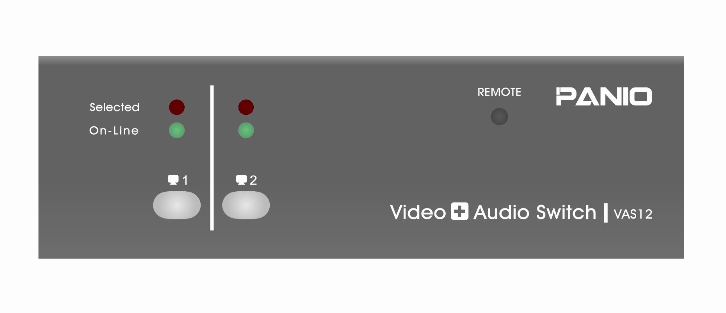
Push Button ( PC selection)

DC 5V 1A Power Jack

VGA port ( PC1 & PC2)

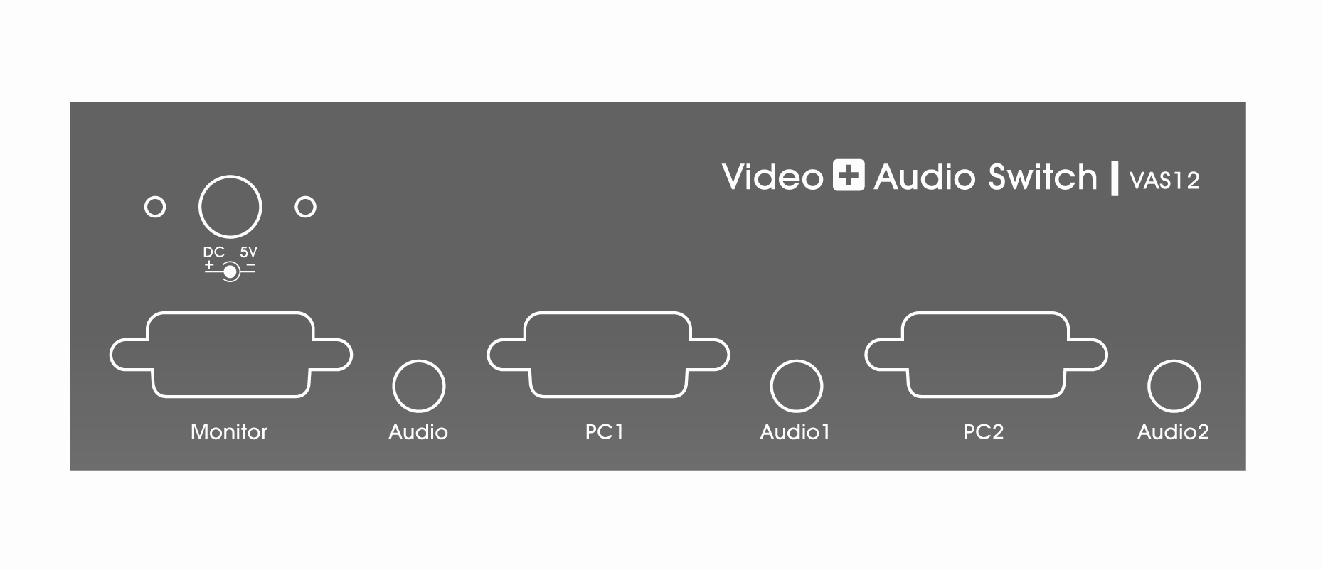
VGA port of Monitor or Projector

Speaker Input Ports
Speaker Output Port

VAS14
LED Indicator (RED): PC selected

LED Indicator (Green): PC On-Line

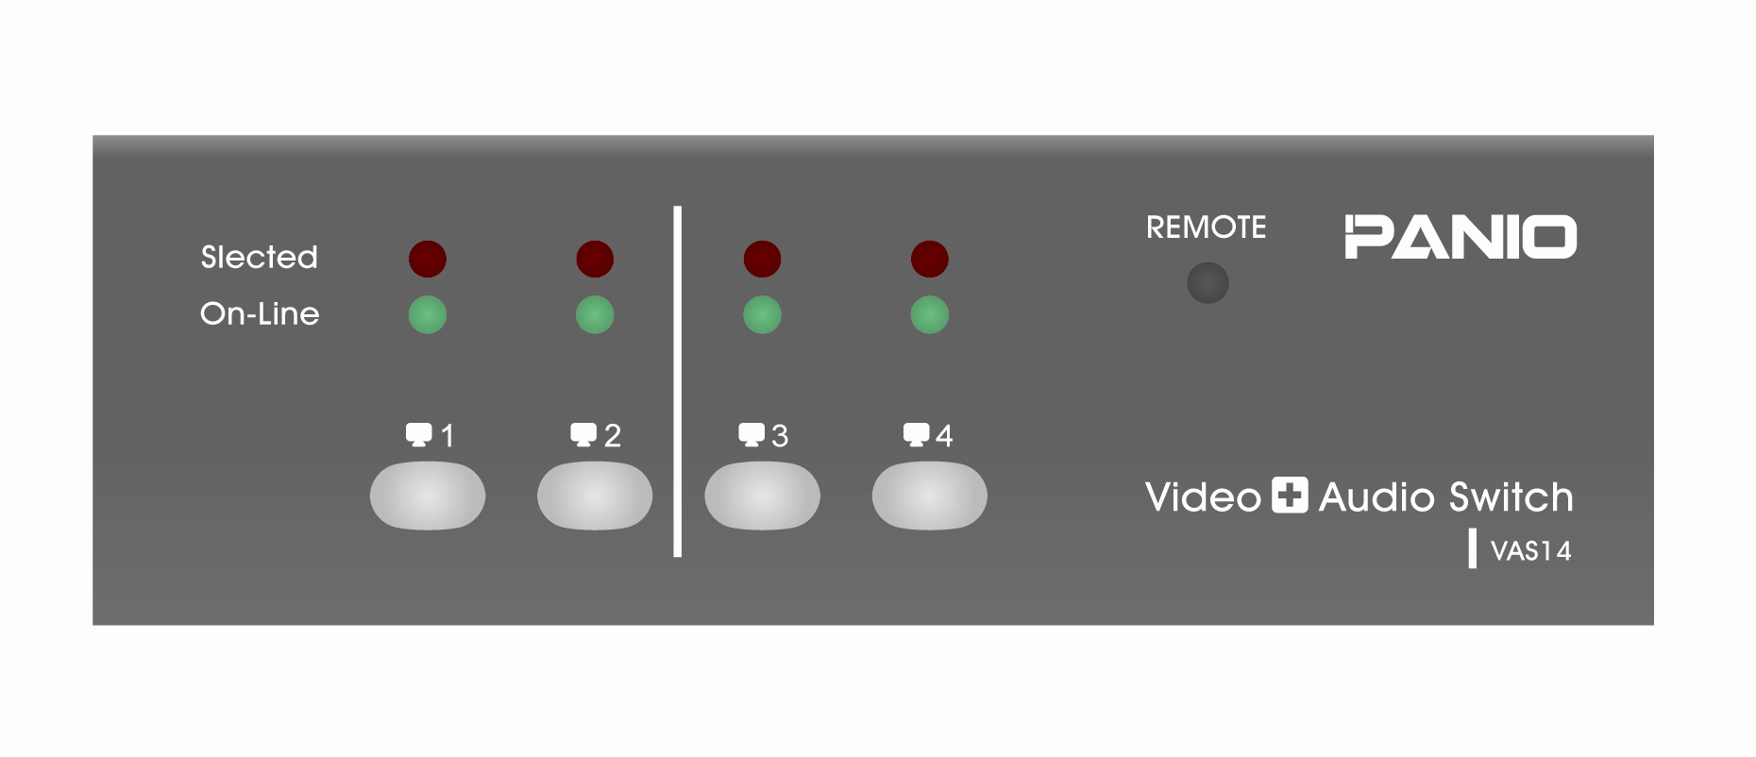

Push Button ( PC selection)

DC 5V 1A Power Jack

VGA port ( PC3 & PC4 )
Speaker Input ports

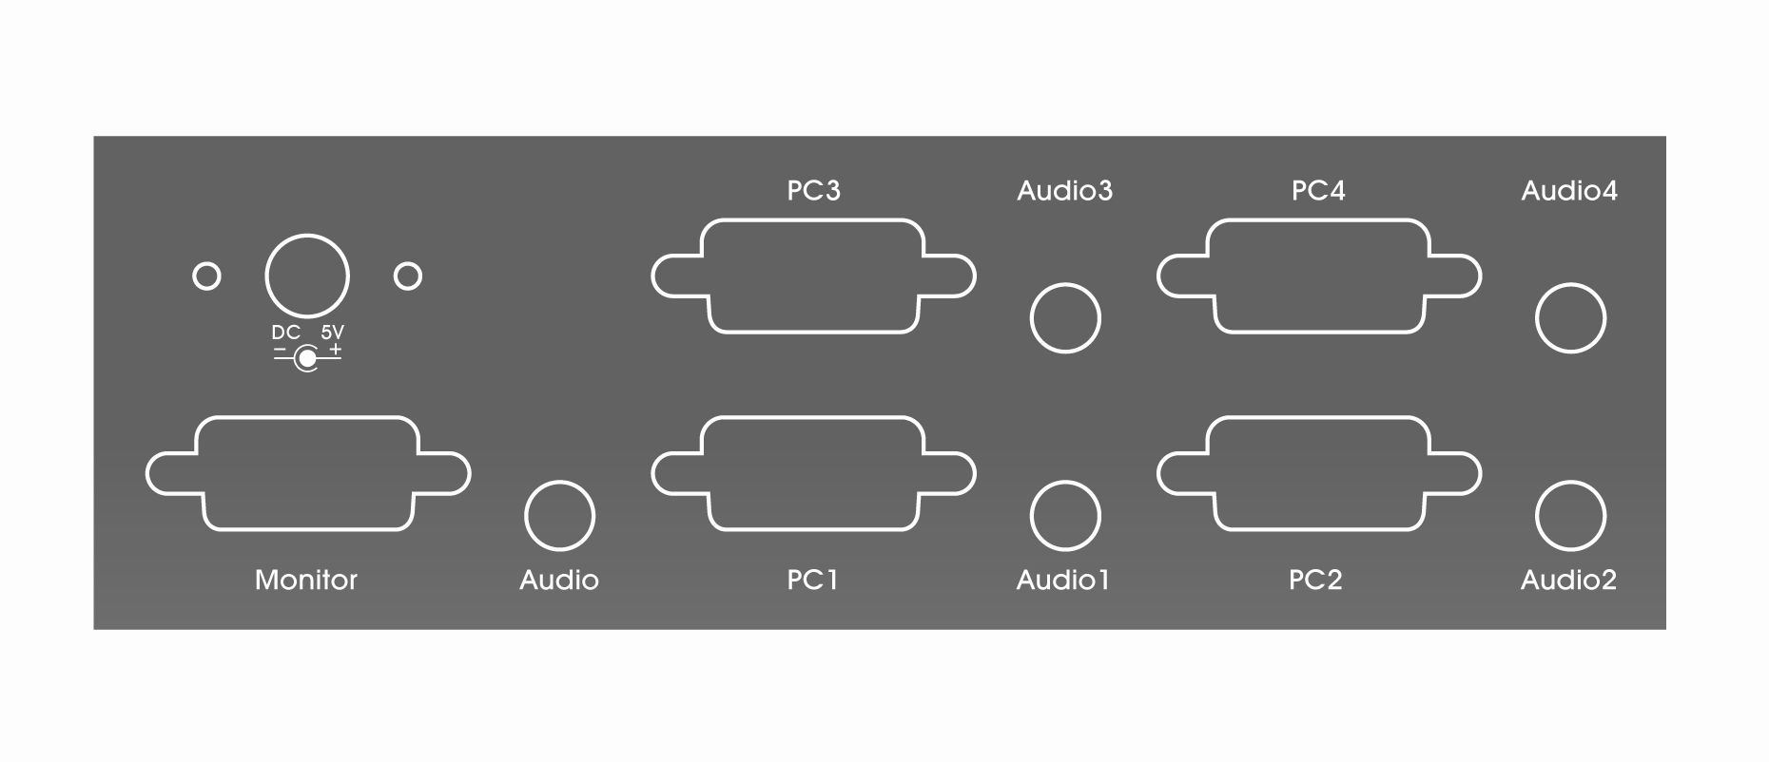

VGA port of Monitor or Projector

VGA port ( PC1 & PC2)

Speaker Input ports
Speaker Output port

3.2.2 VGA Switch Installation

1. Plug in via DC 5V 1A adaptor.
2. Use a HDB15 male to male cable to connect the VGA port of your monitor or projector to the VGA port ( Monitor) of VGA switch.
3. Use a HDB15 male to male cable to connect the VGA port of your computer to the VGA ports of VGA switch ( PC1,2,3,4).
4. Connect the speaker to the audio output ports.
- Operation

4.1 PC Selection:

4.1.1 Push Button:
Press Push Button to select the input source of Video and Audio signal from computers connected.

4.1.2 Remote Control

- Remove the isolation mylar from the IR remote controller before using the IR remote controller.
VAS12 Remote controller
VAS14 Remote controller

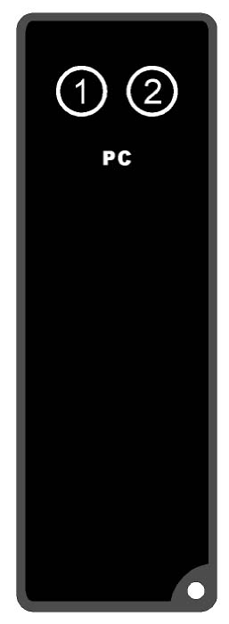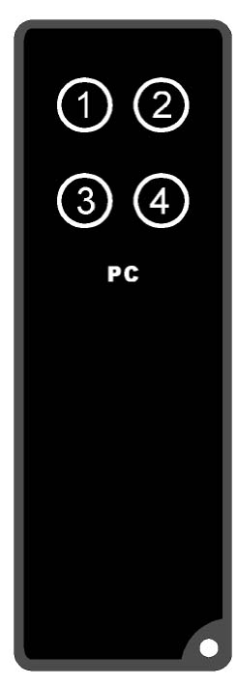
Please remove the Isolation Mylar

2. Press 1,2 ,3 and 4 on IR remote controller to select the input source of Video and Audio signal from computers connected.

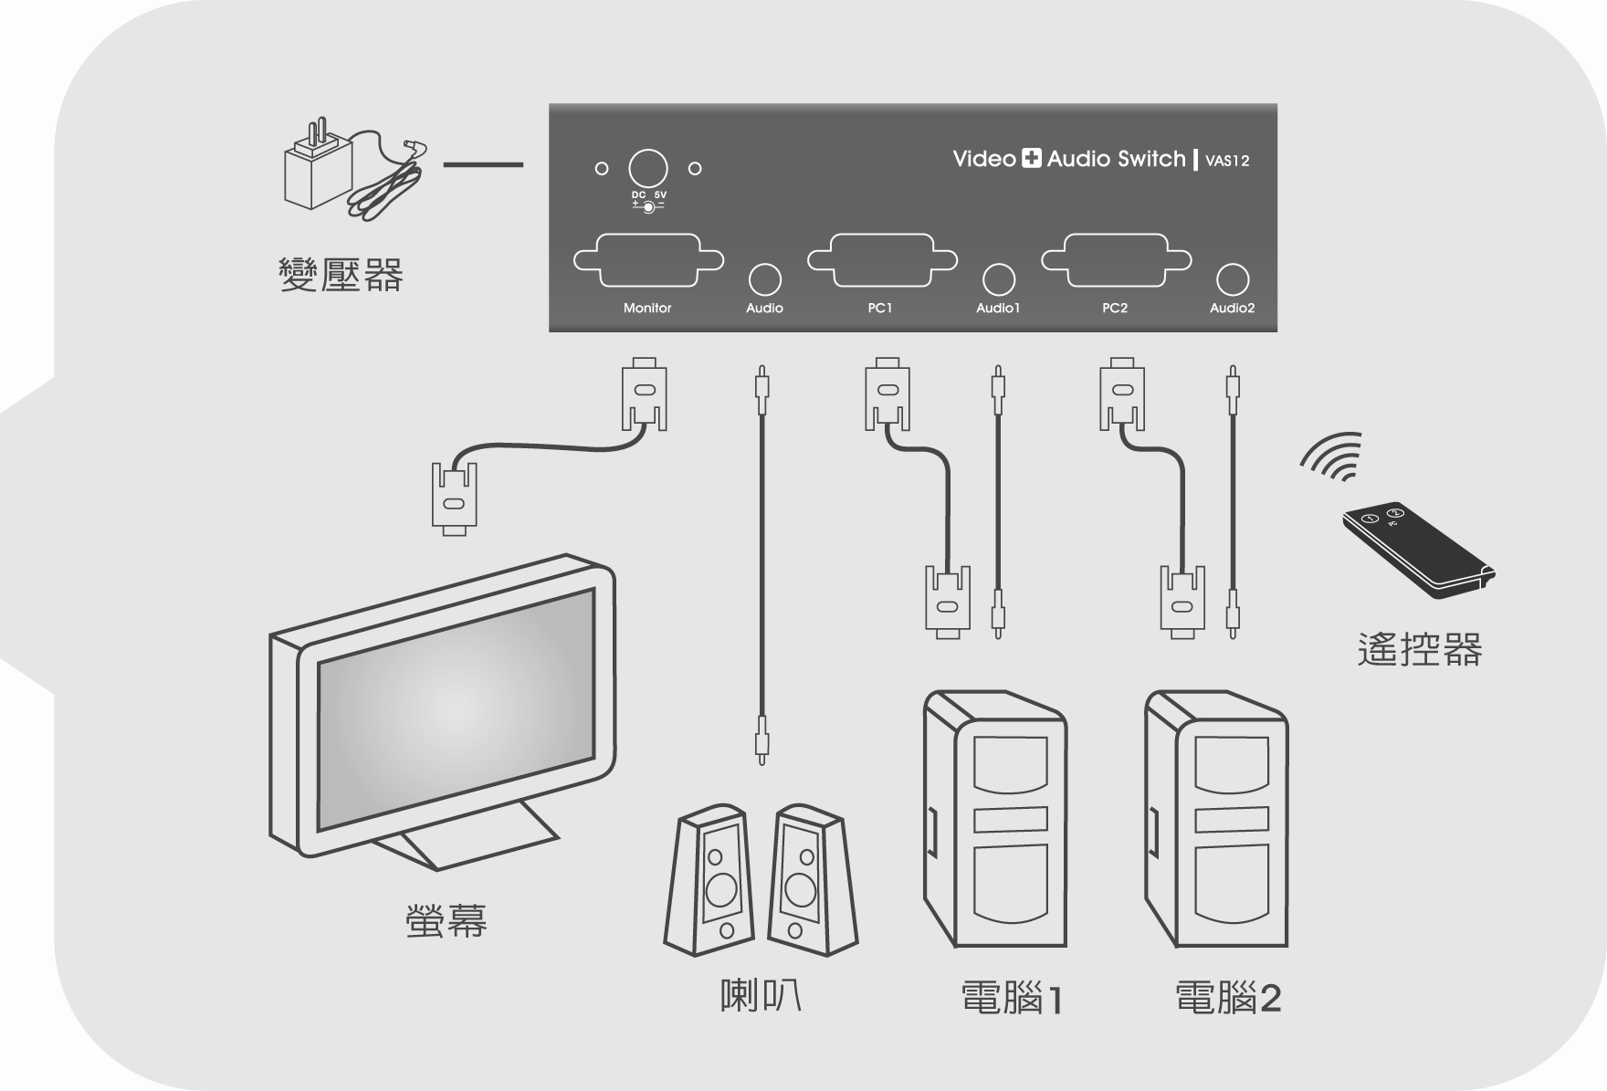

Disclaimer
Information in this document is subject to change without notice. The manufacturer does not make any representations or warranties (implied or otherwise) regarding the accuracy and completeness of this document and shall in no event be liable for any loss of profit or any other commercial damage, including but not limited to special, incidental, consequential, or other damages.

No part of this document may be reproduced or transmitted in any form by any means, electronic or mechanical, including photocopying, recording or information recording and retrieval systems without the express written permission of the manufacturer.

All brand names and product names used in this document are trademarks, or registered trademarks of their respective holders.

FCC Statement
This device generates and uses radio frequency and may cause interference to radio and television reception if not installed and used properly. This has been tested and found to comply with the limits of a Class B computing device in accordance with the specifications in Part 15 of the FCC Rules. These specifications are designed to provide reasonable protection against such interference in a residential installation. However, there is no guarantee that interference will not occur in a particular installation. If this device does cause harmful interference to radio or television reception, which can be determined by plugging the device in and out, the user can try to correct the interference by one or more of the following measures:

- Reorient or relocate the receiving antenna.
- Increase the separation between the device and receiver.
- Connect the computer into an outlet on a circuit different from that to which the receiver is connected.
- Consult the dealer or an experienced radio/TV technician for help.
