

VGA switch & extender with Audio & Remote
User’s Manual

VAS22/VAS44

Version 1.0 2008/08/1

Index
1.
Introduction…………………………………………………………………………………………………2
1.1 Features.…………………….…..………………………………….………………………….…………2
1.2 Package Contents…………………………………...……………..………………………………........2
2. Specifications…………………………………………………………………………………………......3
2.1 General……………………………………………………………...…………………………………….3
3. Connecting the VGA Switch……………………………………………………………………….....3
3.1 System Requirements………………………………………….………………………………………..3
3.2 Connection………...……………………….....................……………..………………………………..4
3.2.1 Diagram of Connections…………………………………………………………………………........4
3.2.2 Metrix VGA Switch Installation………………………………………………………………………..6
4. Operation……………………………………………………………………….…….…………………….6
4.1 Push Button………………….…..…………………………………………………………………........6
4.2 IR Remote Control…………………………………………………………………………………........6

Appendix (附錄)
Quick Guide (快速使用說明)….………………......................................................................7

- Introduction

Thank you for purchasing the 2/4 port Matrix VGA Switch & Extender with Audio & Remote! We recommend that you read this manual thoroughly and retain for future reference.

  - Features

The 2/4 port Matrix VGA Switch & Extender with Audio & Remote allows you to display up to four computer’s video inputs on two or four monitors or projectors. Daisy-chain more than one switcher to expand the number of computers you can connect. With the built-in video signal enhancement, you can place the monitor up to 210 feet away while maintaining your video quality .No software is required and PC selection is easy. Switch between computers via push buttons or use the remote control for PC selection from up to 6 feet away. From use in test bench facilities, data centers and help desks, to classrooms, and multi-media centers, the 2/4 port Matrix VGA Switch & Extender with Audio & Remote delivers both performance and value.

- Display up to four video inputs from two or four computers on two or four monitors or projectors.
- PC selection via push buttons or IR remote control
- IR remote control allows you to switch outputs from up to 6 feet away
- Support Daisy-chain to expand the number of computers connection up to 3 layers.
- Enhance video signal enhancement allows monitor to be placed up to 210 feet away
- Supports video resolutions up to 2048x1536
- Suitable for VGA, SVGA, XGA, SXGA, UXGA, and Multisync monitors

  - Package Contents

1 x VAS22 / VAS44
1 x IR remote Controller
1 x DC5V 1A Power adaptor
1 x User's Manual

2. Specifications

2.1 General

VAS22/VSA44 Specification
Number Of Computers Controlled |  | 2 or 4 computers
Selection Method |  | Push Button or IR Remote Control
LED indicators |  | Green for PC Selected
 |  | Green for PC ON-Line
PC connector ports | Video | 2 or 4 x HDB-15 female
PC connector ports | Speaker | 2 or 4 x Stereo speaker jacks
Console Ports | Video | 2 or 4 x HDB-15 female
Console Ports | Speaker | 2 or 4 x Stereo speaker jacks
DDC, DDC2 monitor |  | Yes (Max. Resolution:2048x1536)@85Hz
Maximum Bandwidth |  | 450 MHz
Power |  | DC 5V 1A
Dimensions (LxWxH) |  | VAS22:14 x 8.5 x 4.5 (cm) VAS44:21.5 x 8.8 x 4.5 (cm)
Unit Weight |  | 400g (VAS22) / 620g (VAS44)

3. Connecting the VGA Switch

3.1 System Requirements
- Requires two or four HDB15 male to male cables to connect your monitors or projectors through HDB15 female ports
2. Requires two or four HDB15 male to male cables to connect your computers through HDB15 female ports

3.2 Connection

3.2.1 Diagram of Connections

VAS22
LED Indicator (RED): PC selected

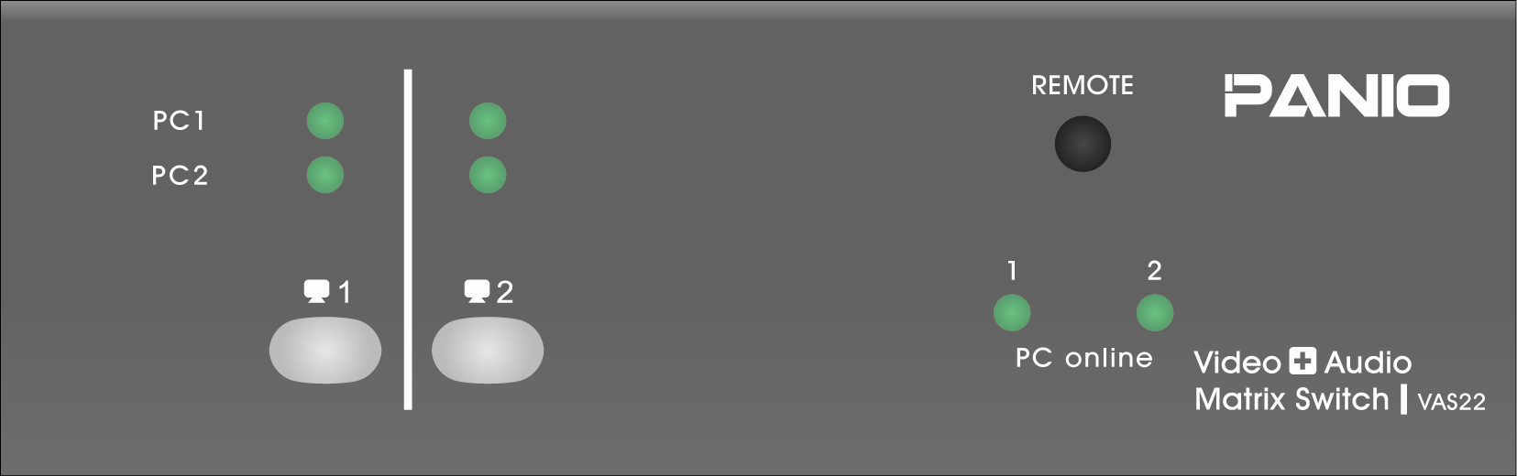

LED Indicator (Green): PC On-Line

Push Button (Monitor)

VGA port (PC1 & PC2)
Speaker Output Ports
DC 5V 1A Power Jack

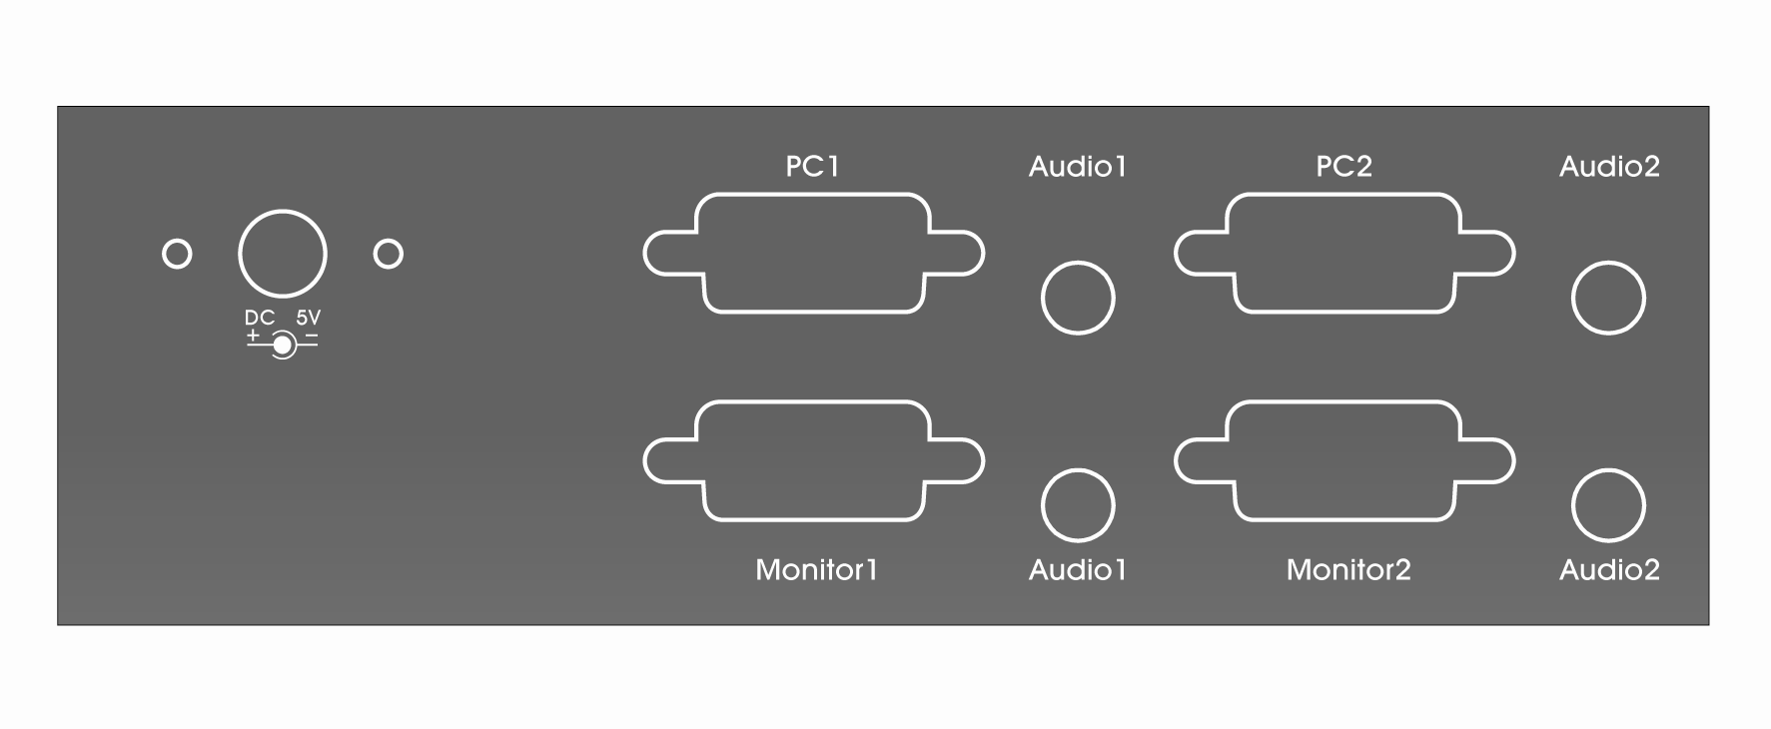

VGA port (Monitor 1 & Monitor 2)
Speaker Input Ports

VAS44
LED Indicator (Green): PC (Audio Inputs) selected for each monitor connected

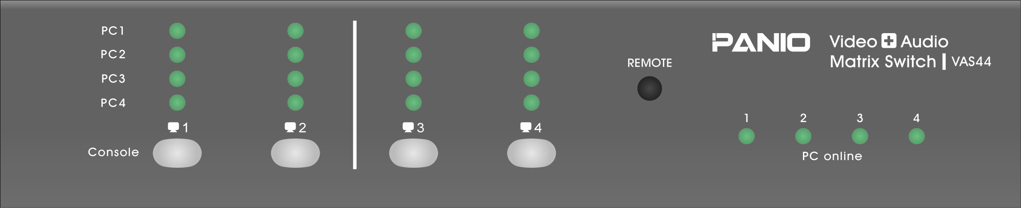

LED Indicator (Green): PC On-Line

Push Button (Monitor)

DC 5V 1A Power Jack

VGA port (PC1, PC2, PC3 & PC4)
Speaker Input Ports

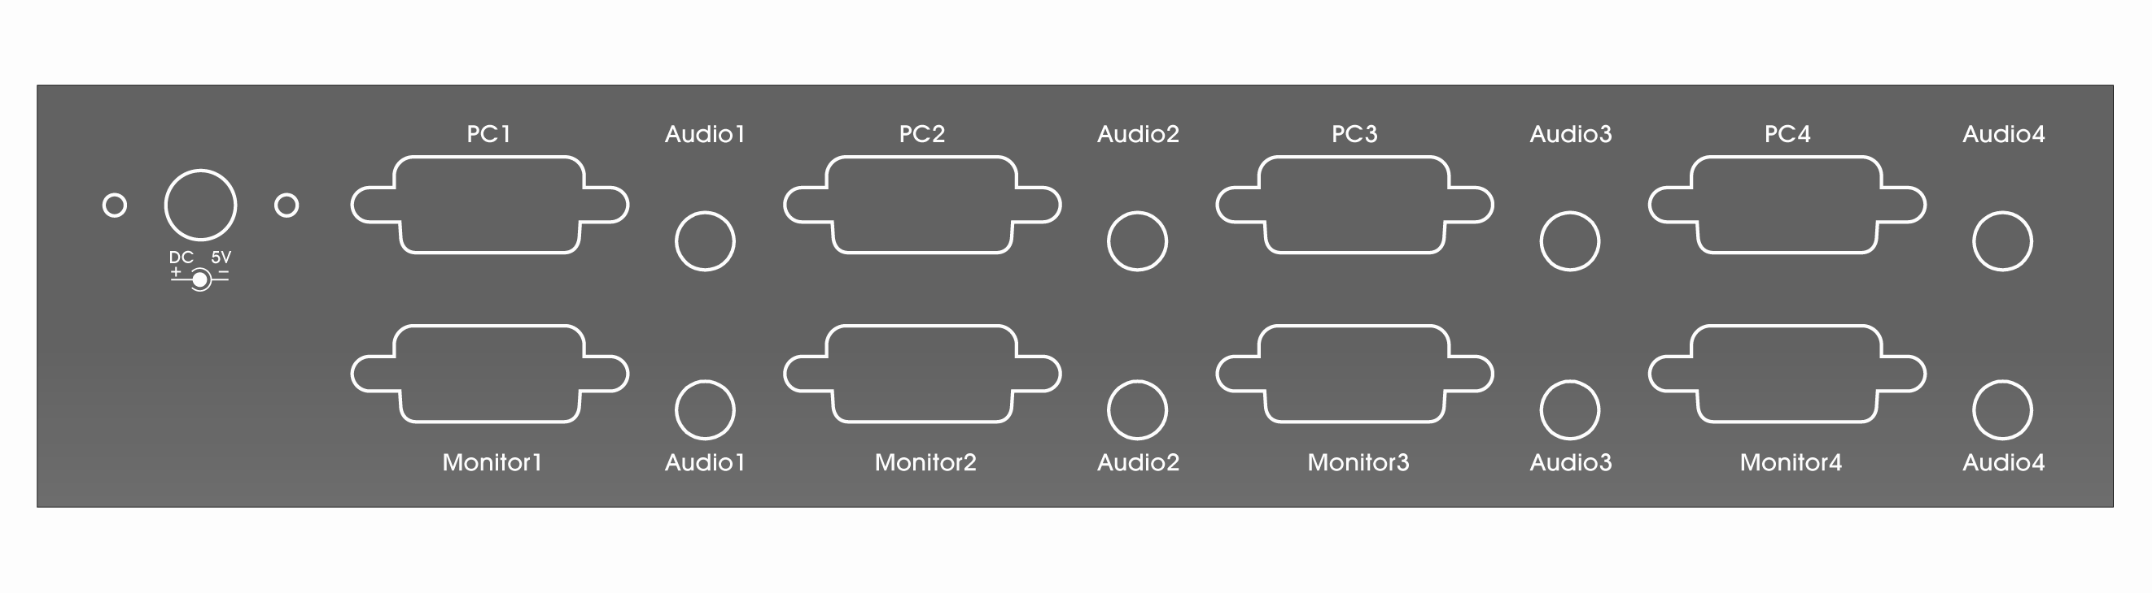

VGA port (Monitor 1, Monitor 2,
Monitor 3 & Monitor 4)
Speaker Output ports

3.2.2 Matrix VGA Switch Installation

1. Plug in via DC 5V 1A adaptor.
2. Use HDB15 male to male cables to connect the VGA ports of your monitors or projectors to the VGA ports of VGA switches.
3. Use HDB15 male to male cables to connect the VGA port of your computer to the VGA ports of VGA switches.
4. Connect the speaker to the audio output ports.

- Operation

4.1 Push Button (Monitor) :
- Each Push Button corresponds to a certain display output source (Monitor or Projector).
- Press Push Button to select the input sources of Video and Audio signal from the computers connected for the certain monitor or projector which you want to display the video outputs.
- The selected computer will be switched to the next one when you press the push button again.

4.2 IR Remote Control
VAS22 Remote controller
VAS44 Remote controller
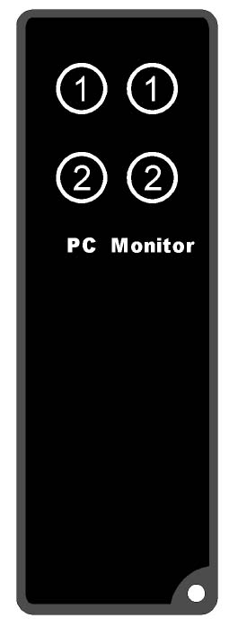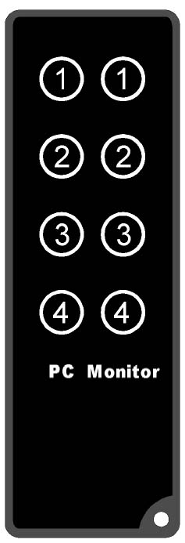
Please remove the Isolation Mylar before using

- Remove the isolation mylar from the IR remote controller before using the IR remote controller.
- Press Monitor 1,2 ,3 and 4 on IR remote controller to select the connected monitors to display the video outputs.

- Press PC 1,2 ,3 and 4 on IR remote controller to select the input source of Video and Audio signal from computers connected.

Appendix (附錄)
快速使用說明:
1 按下按鍵，按一次選擇PC1訊號源，按二次選擇PC2訊號源
按三次選擇PC3訊號源，按四次選擇PC4訊號源
依次循環切換選擇

2 被選擇到之PC訊號源會亮綠燈

Disclaimer
Information in this document is subject to change without notice. The manufacturer does not make any representations or warranties (implied or otherwise) regarding the accuracy and completeness of this document and shall in no event be liable for any loss of profit or any other commercial damage, including but not limited to special, incidental, consequential, or other damages.

No part of this document may be reproduced or transmitted in any form by any means, electronic or mechanical, including photocopying, recording or information recording and retrieval systems without the express written permission of the manufacturer.

All brand names and product names used in this document are trademarks, or registered trademarks of their respective holders.

FCC Statement
This device generates and uses radio frequency and may cause interference to radio and television reception if not installed and used properly. This has been tested and found to comply with the limits of a Class B computing device in accordance with the specifications in Part 15 of the FCC Rules. These specifications are designed to provide reasonable protection against such interference in a residential installation. However, there is no guarantee that interference will not occur in a particular installation. If this device does cause harmful interference to radio or television reception, which can be determined by plugging the device in and out, the user can try to correct the interference by one or more of the following measures:
- Reorient or relocate the receiving antenna.
- Increase the separation between the device and receiver.
- Connect the computer into an outlet on a circuit different from that to which the receiver is connected.
- Consult the dealer or an experienced radio/TV technician for help.


